**MIT xPRO Data Engineering Certificate**

**Databases & SQL**

**Database Design**

Conceptual design refers simply to when an engineer designs a database, its tables, and the relationships between them.

Logical design refers to the design step where one considers more carefully what each table should capture and how the data will be utilized.

*Primary keys,* also called unique identifiers, help you access any record in your table distinctively. Naturally, a good choice for a *primary key* is of paramount importance in the process of database design to guarantee efficiency. SQL also includes *foreign keys*—these are helpful to access data and move it from one table to another.

*Cardinality* is used to determine the relationship between the tables in a data model. There are different types of relationships: 1-to-1, 1-to-N (one-to-many), or N-to-N (many-to-many).

*Normalizing* data includes a set of practices that primarily aim to avoid redundancy in the data, improve integrity, and eliminate duplicate records. You will also see that *normalization* includes ensuring that no data is lost when splitting tables into smaller ones.

To make an ER diagram, you need to define the *entities*, *properties*, *primary keys*, and relationships between tables.

*Indexing* a table is useful to enforce a unique constraint and speed up the *queries*. Contrary to *primary* *keys*, *indexes* are associated with columns and don’t have to be unique.

The main components of SQL are DQL (Data Query Language), DDL (Data Definition Language), DCL (Data Control Language), and DML (Data Manipulation Language).

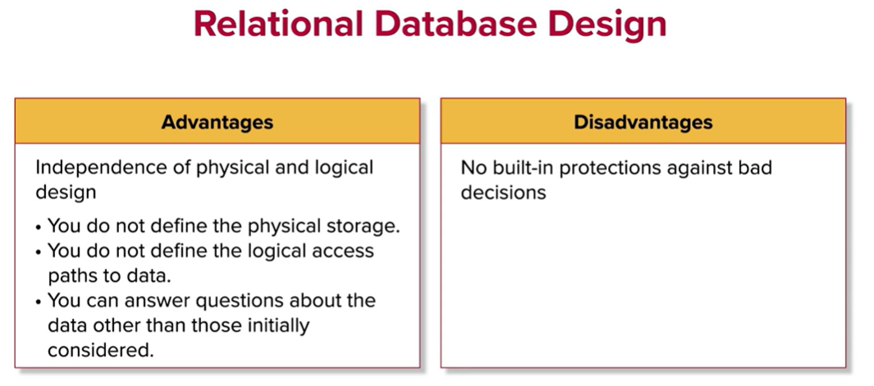

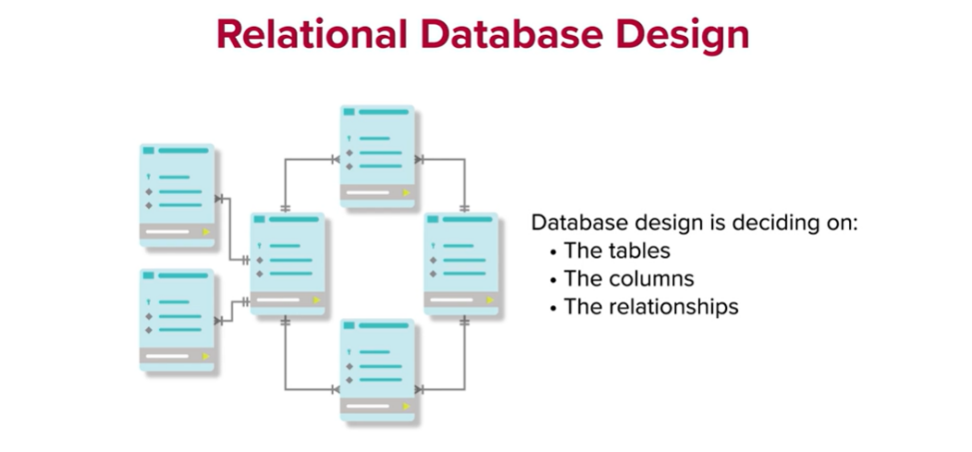

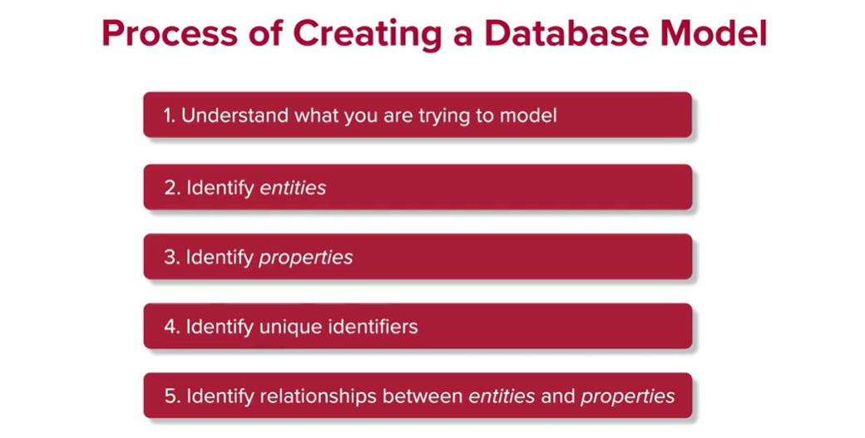

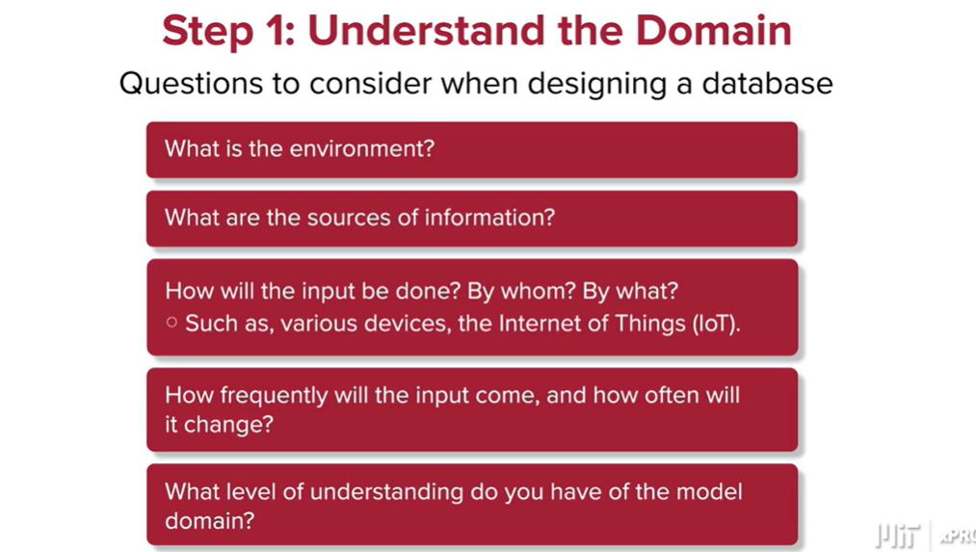

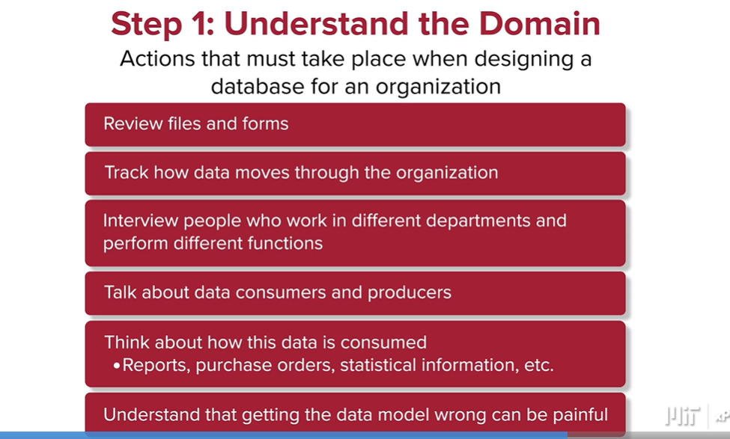

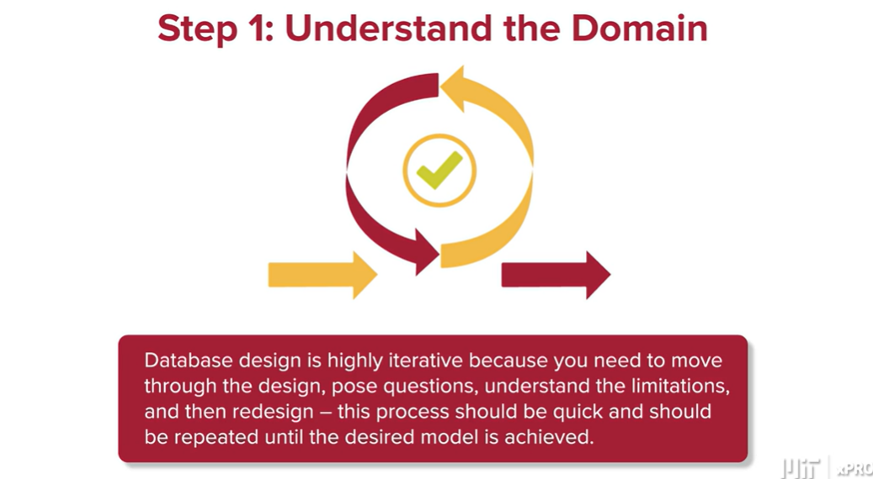

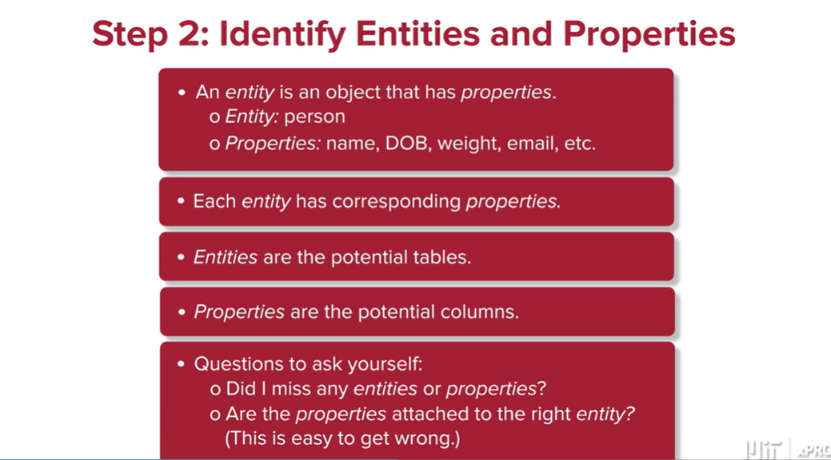

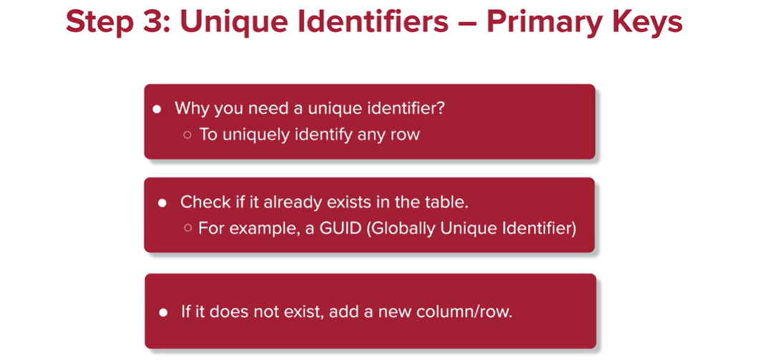

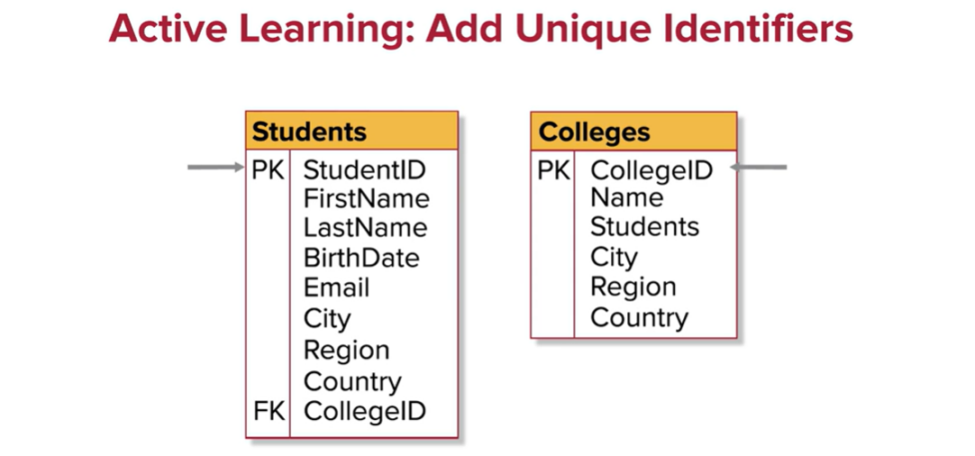

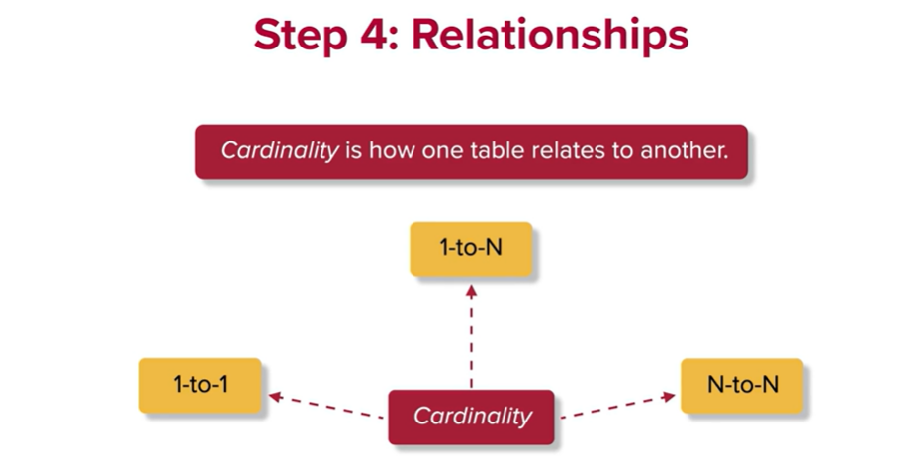

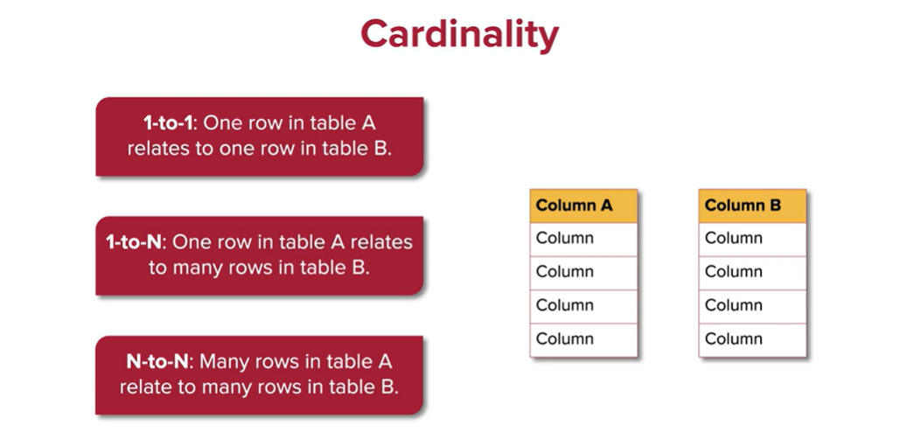

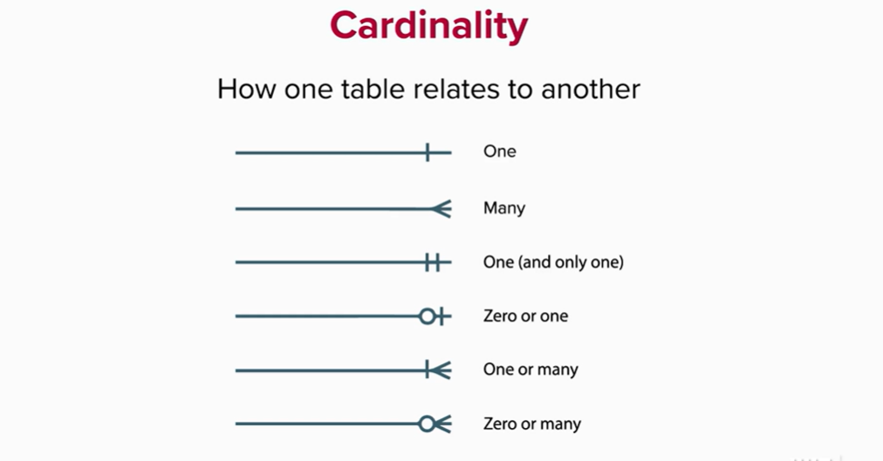

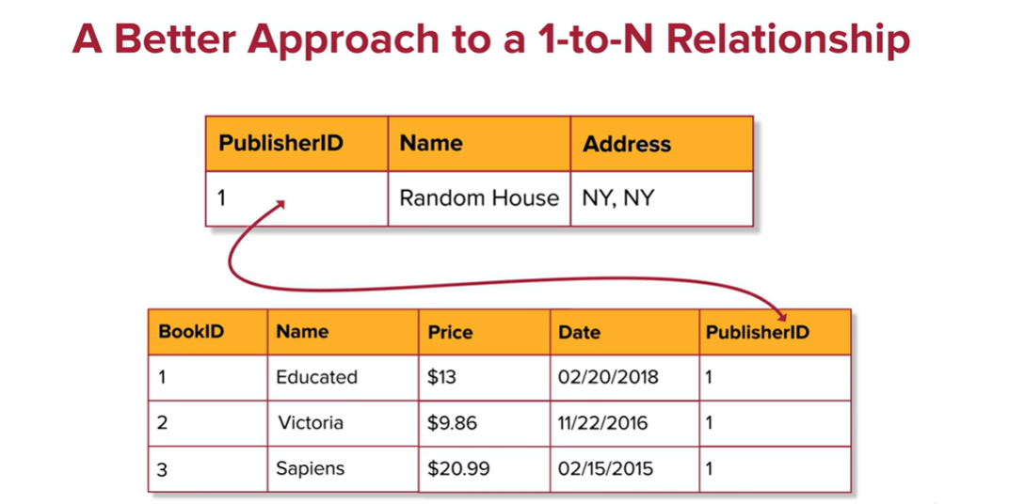

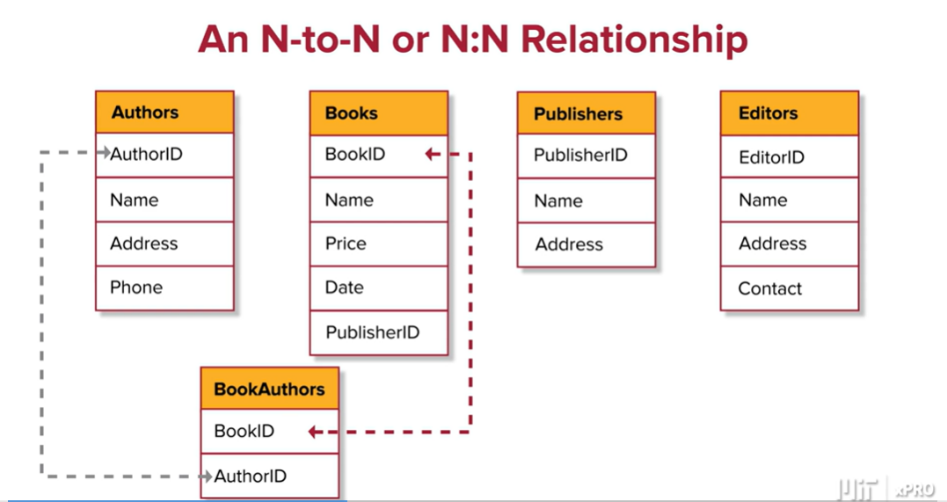

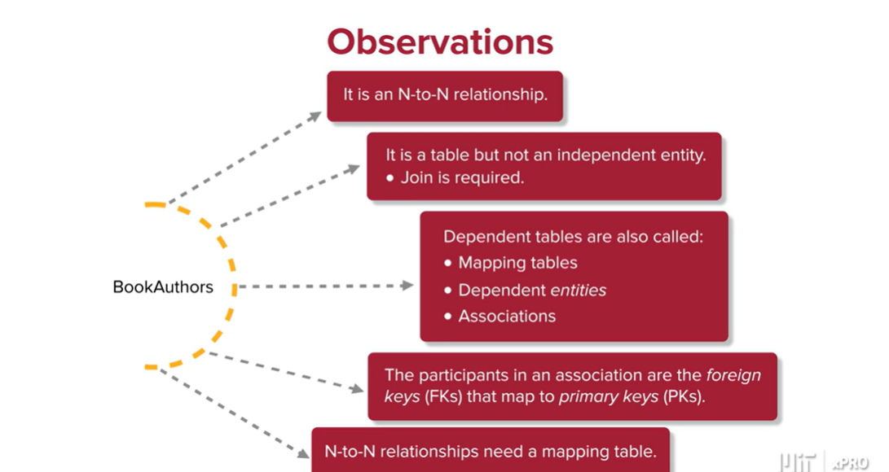

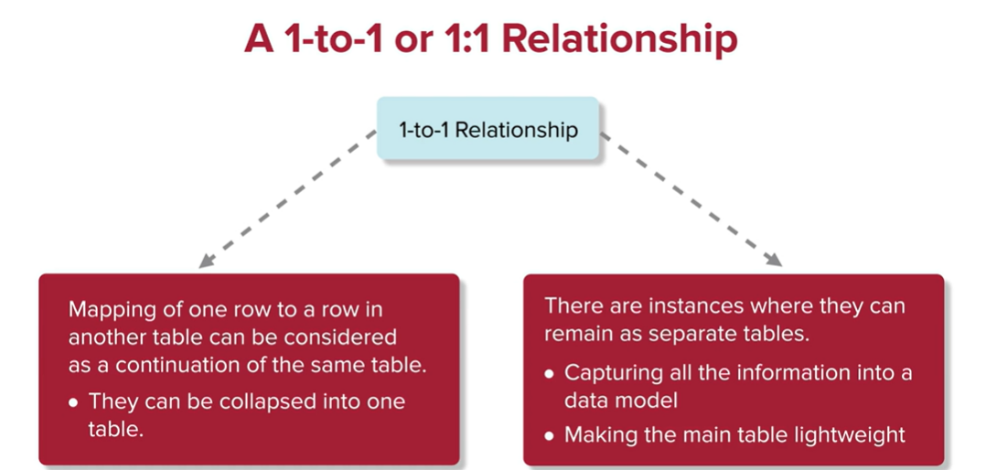

In this case, many students each have one college:

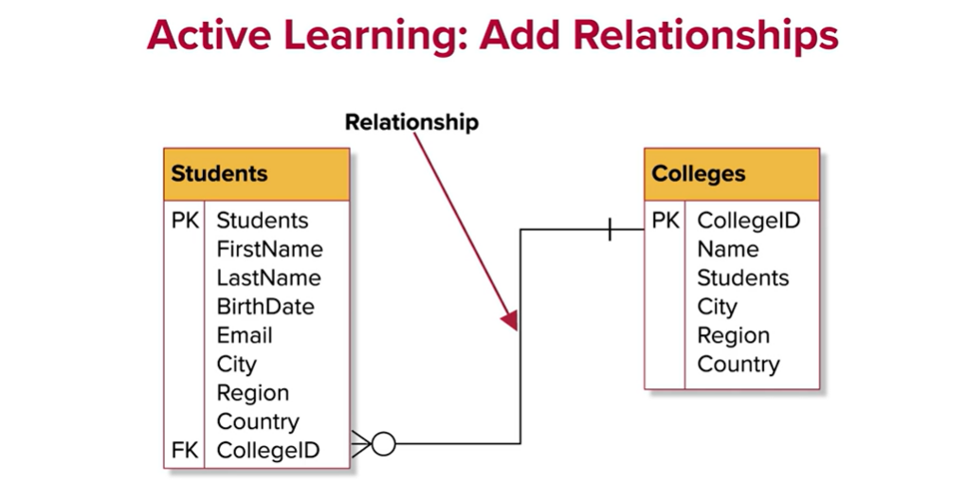

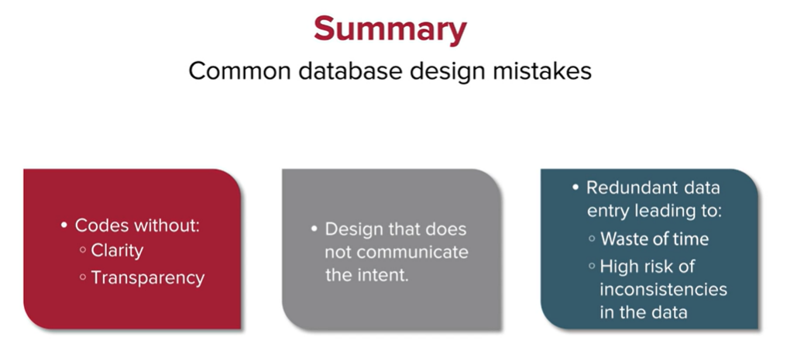

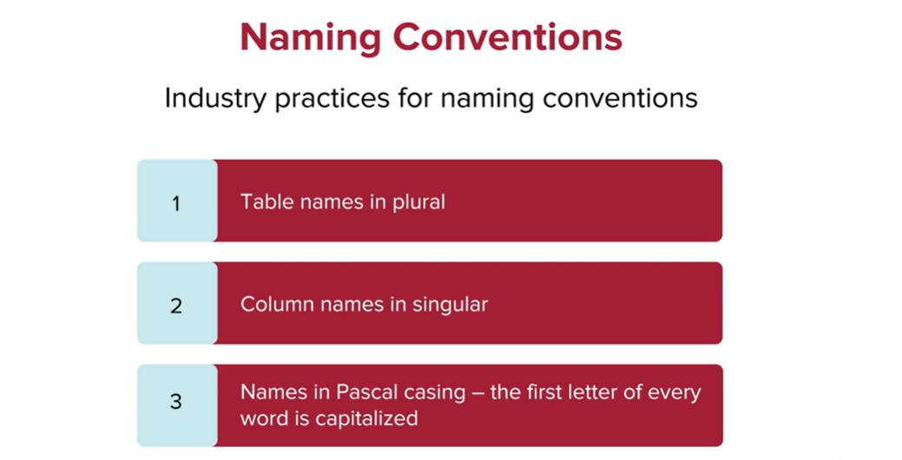

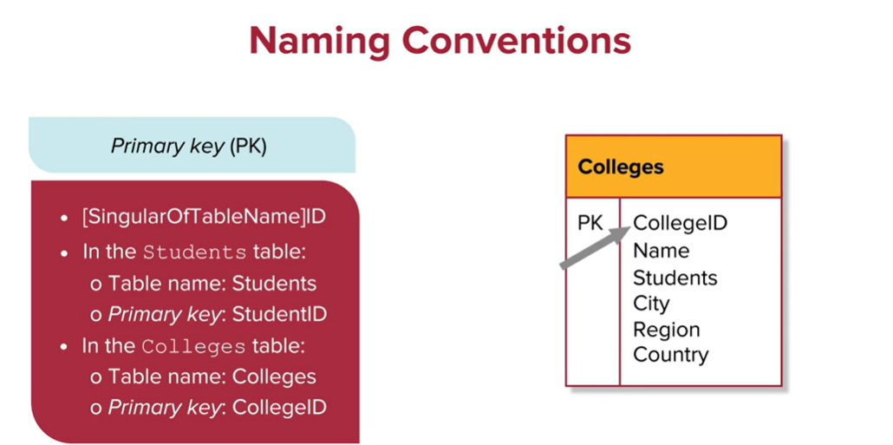

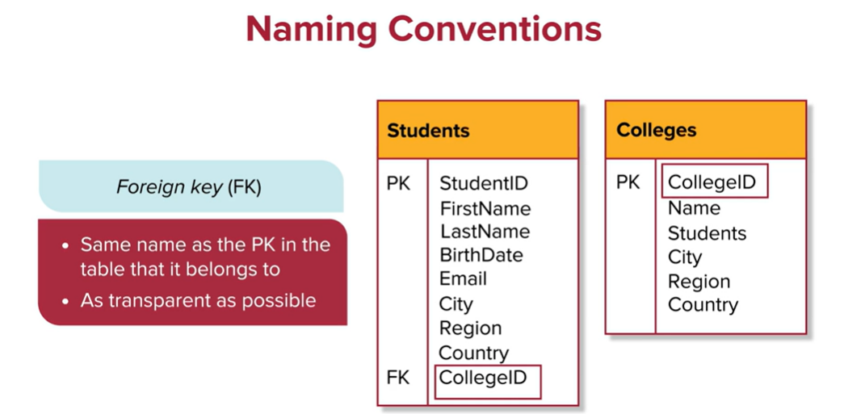

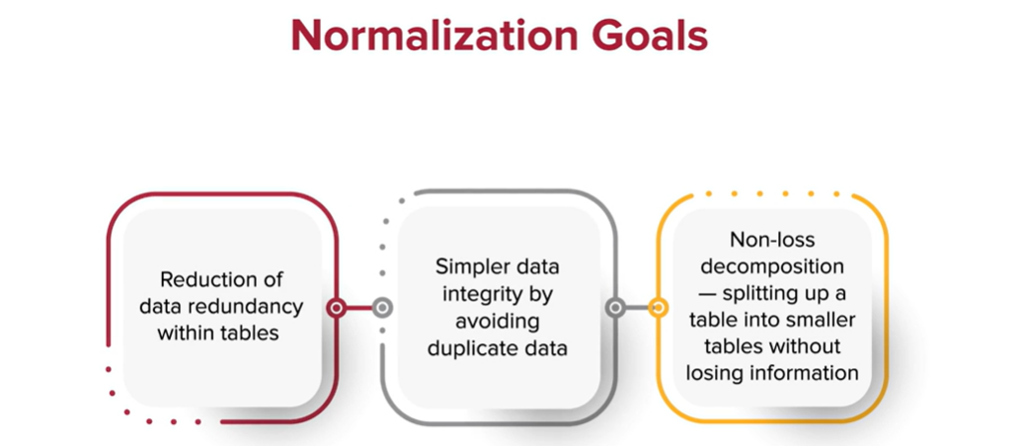

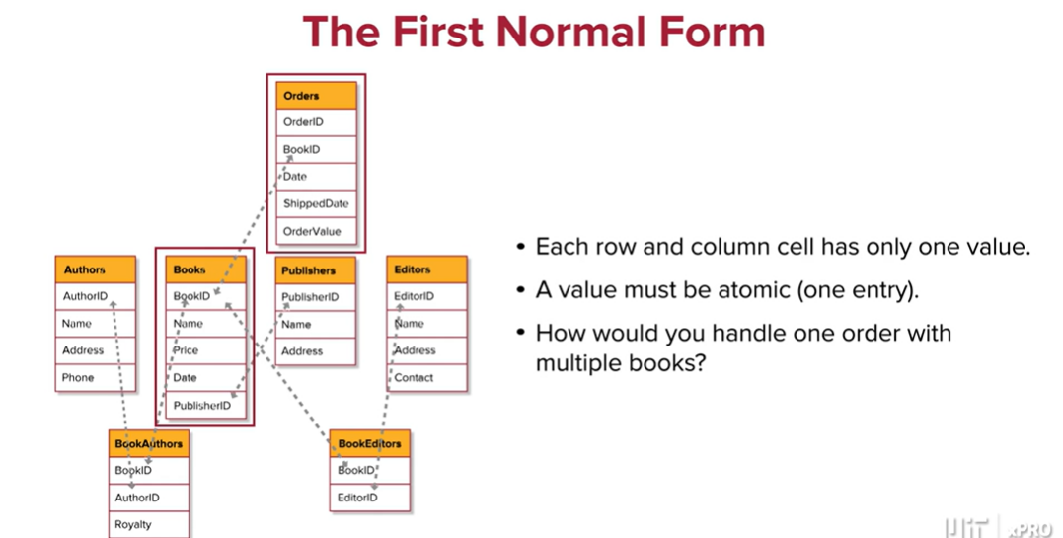

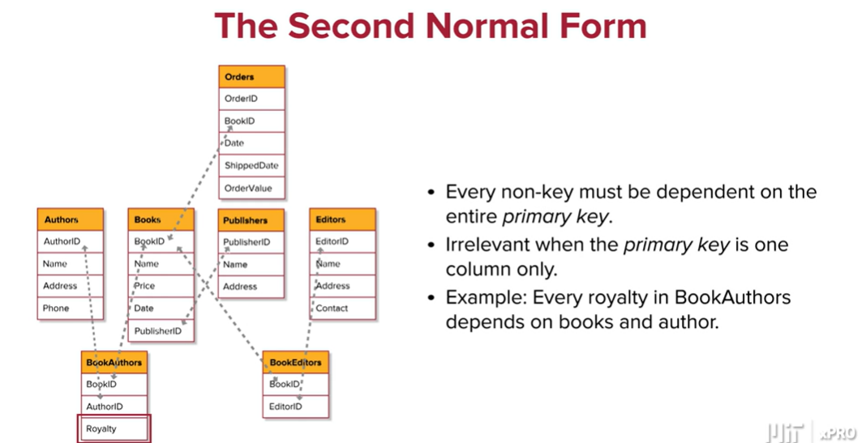

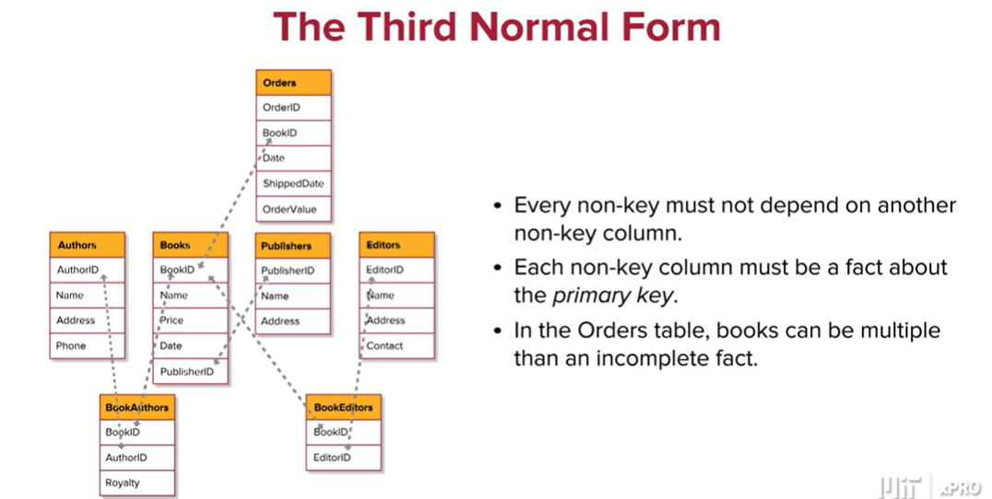

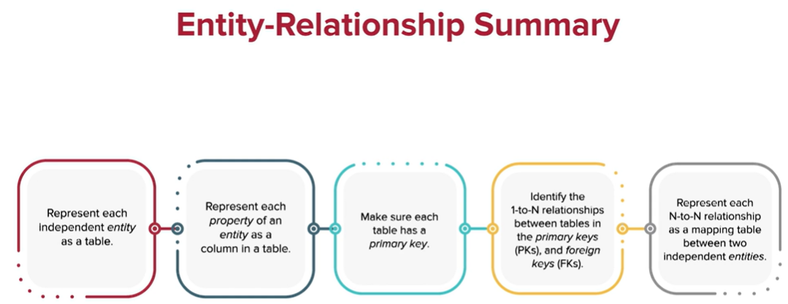

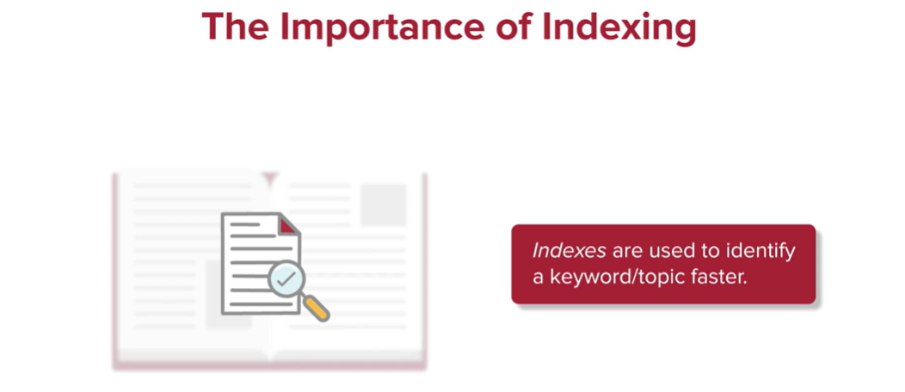

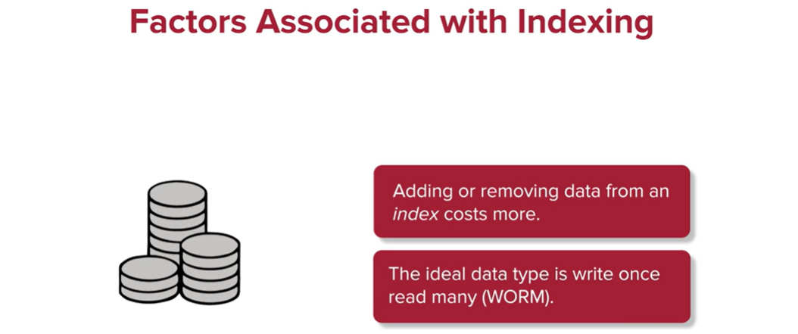

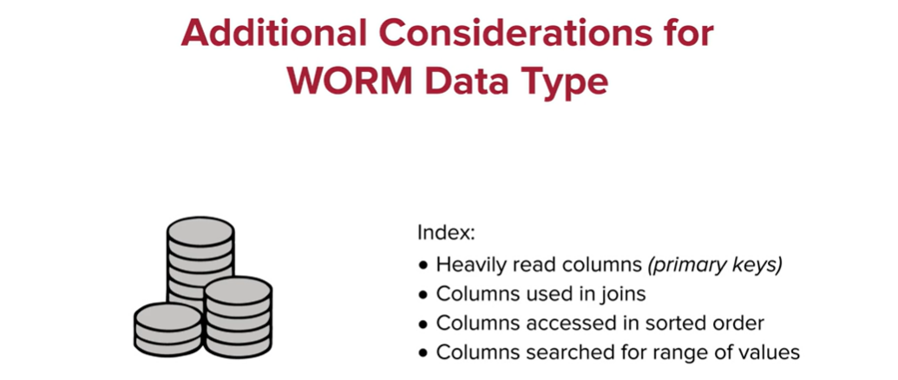

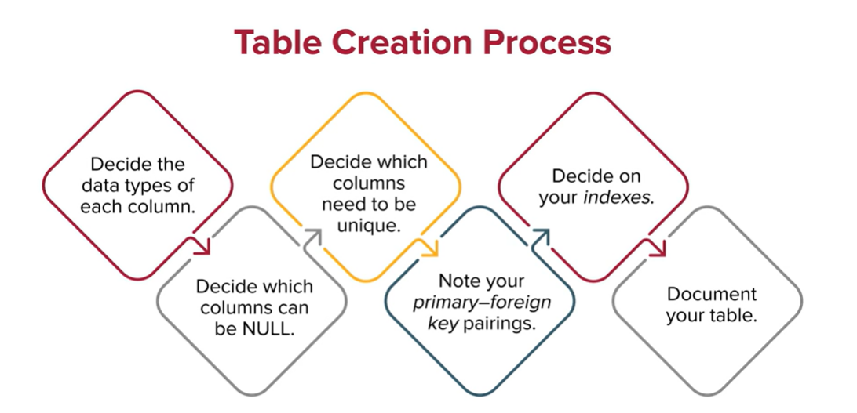

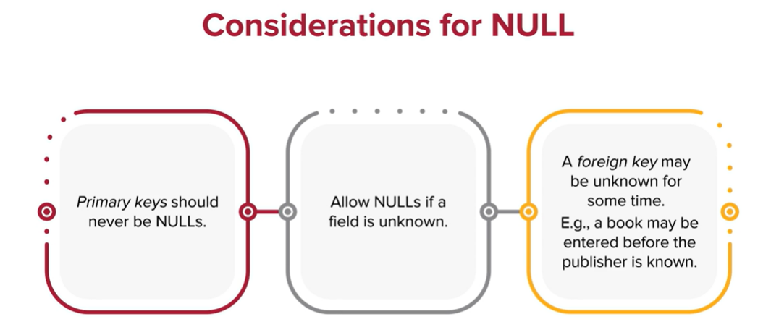

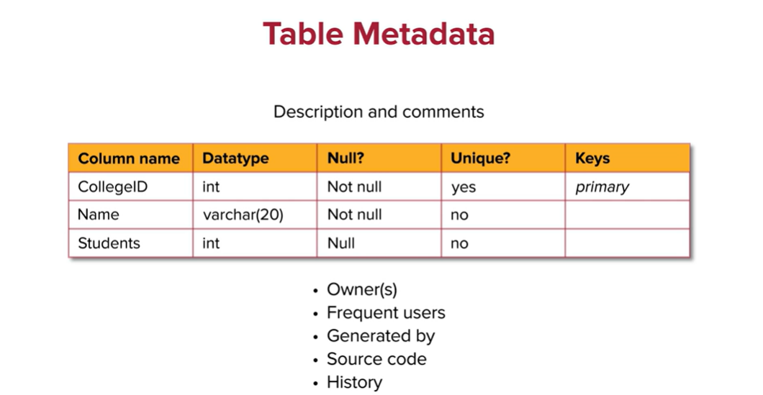

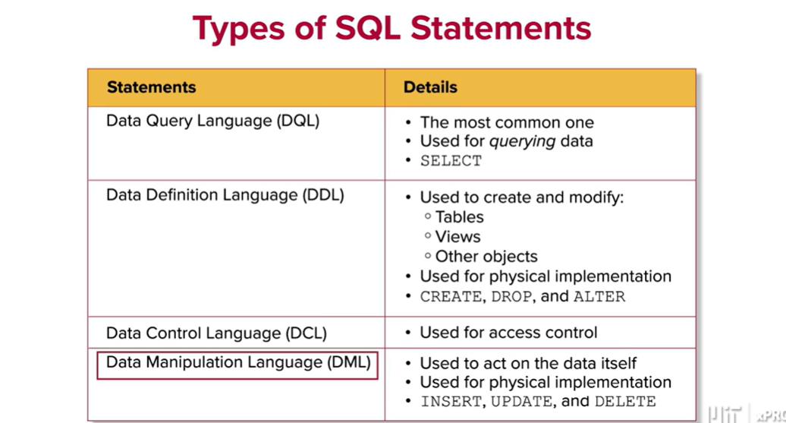

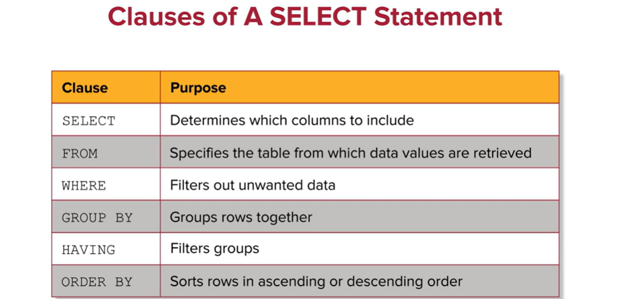

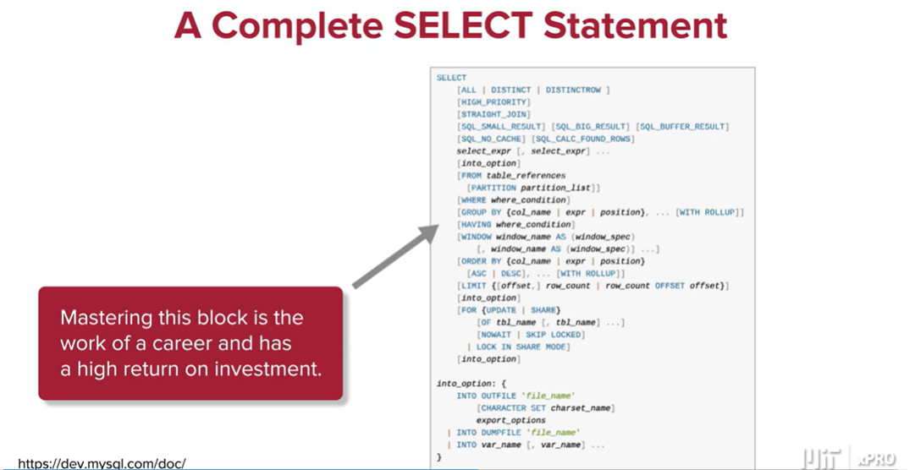

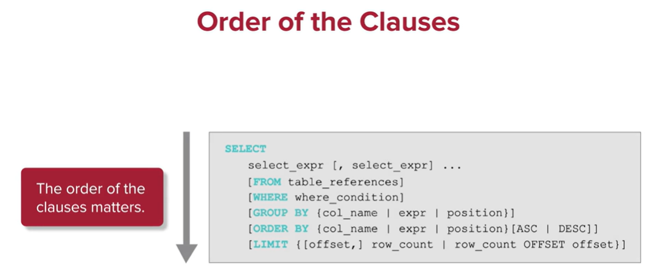

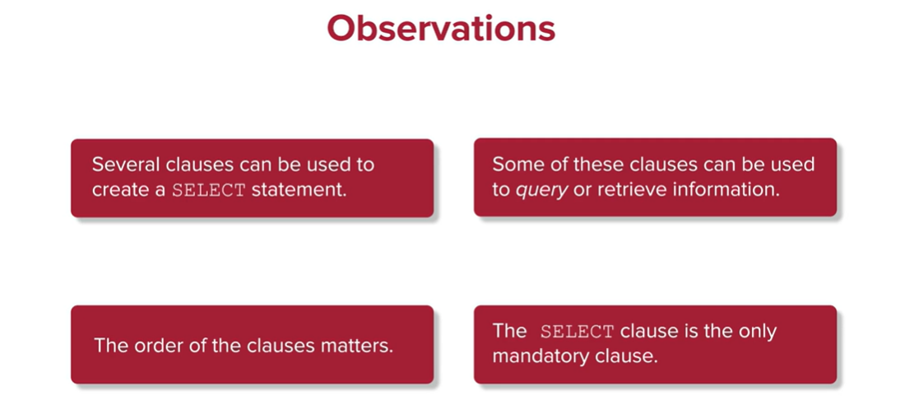

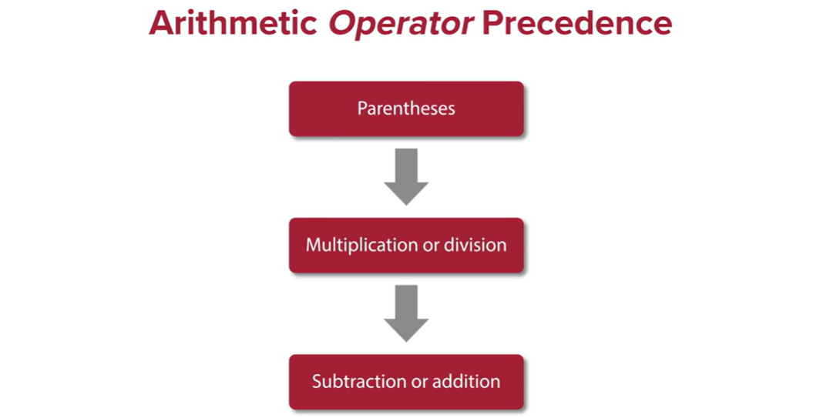

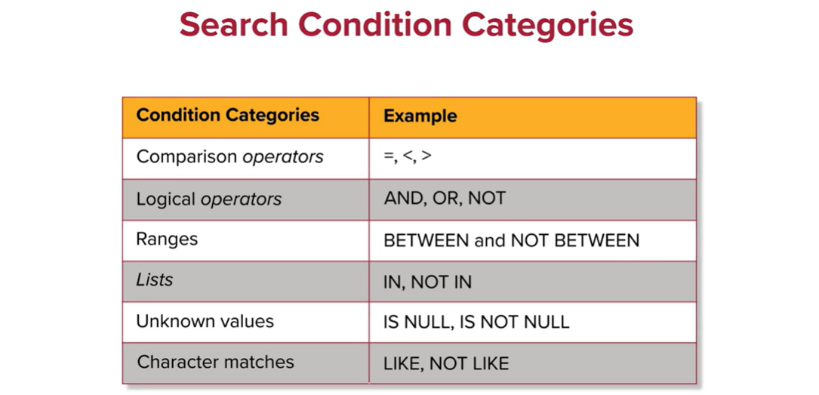

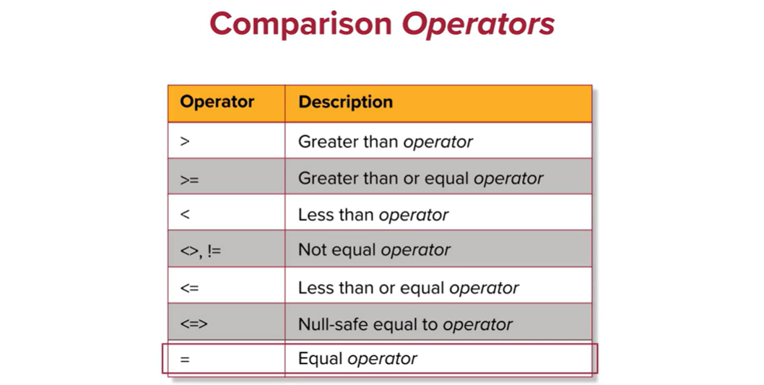

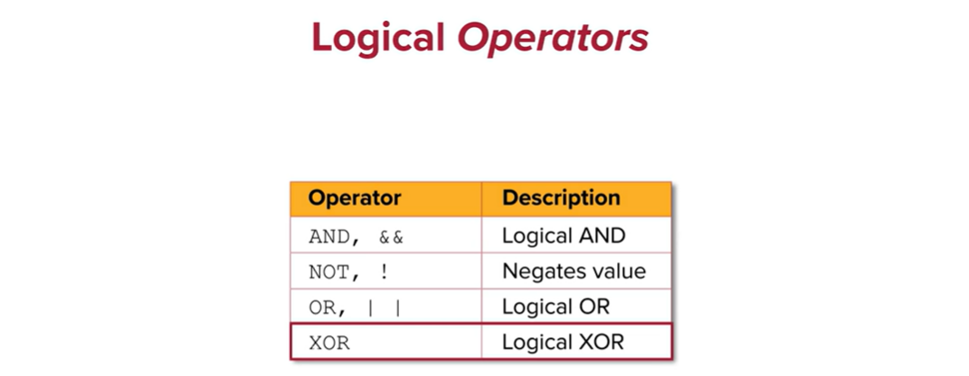

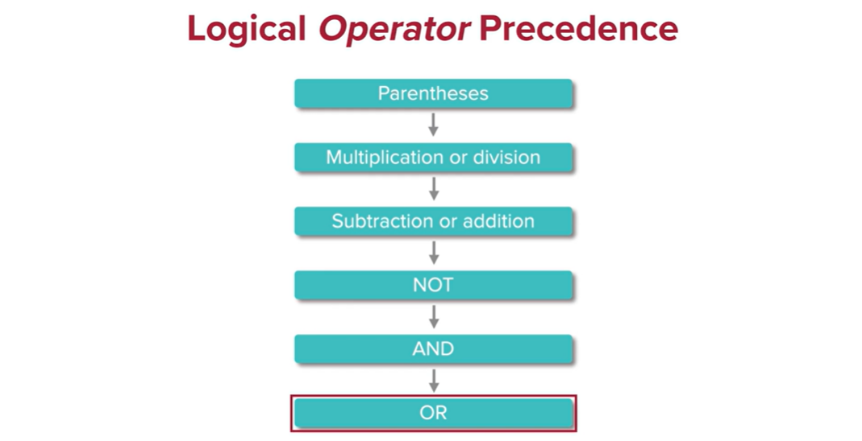

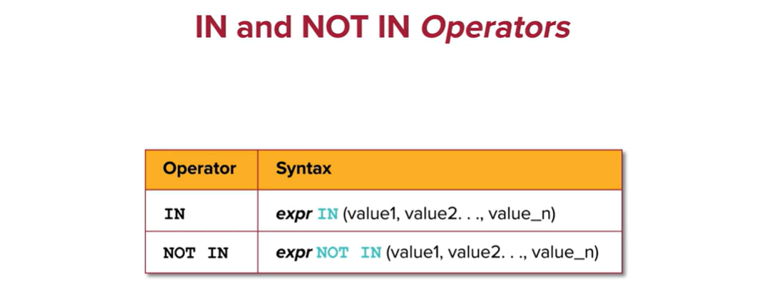

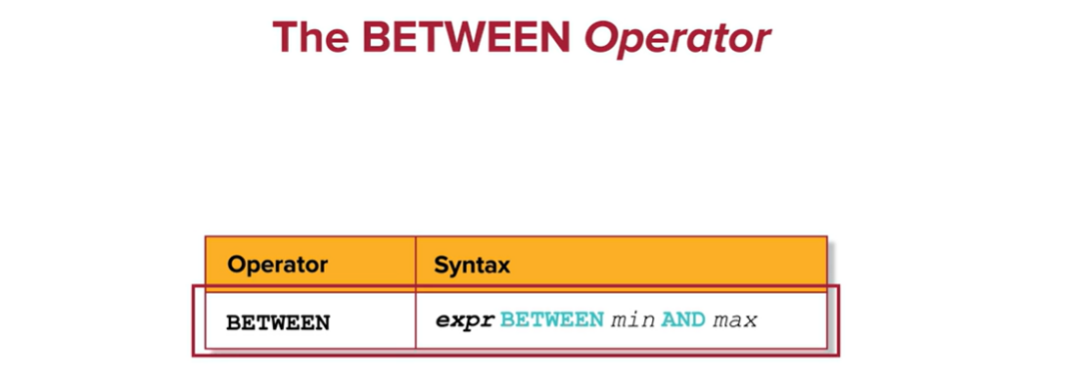

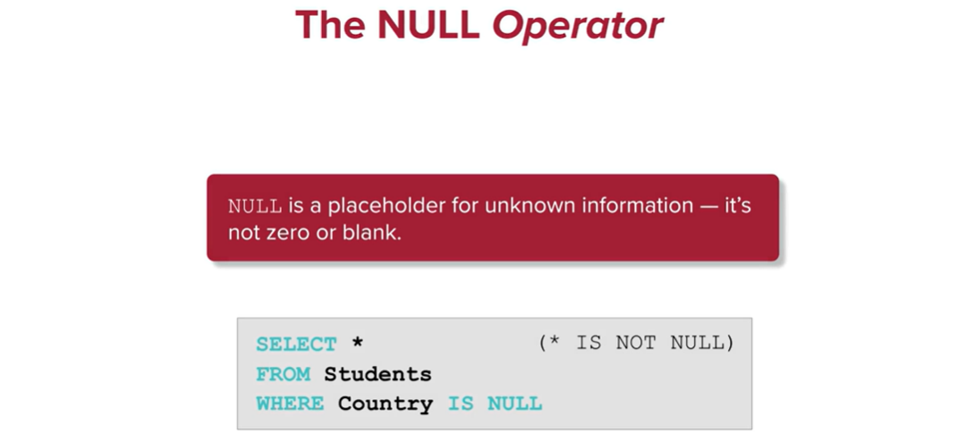

The LIKE *operator* is used to identify patterns in data by determining the presence of matching characters:

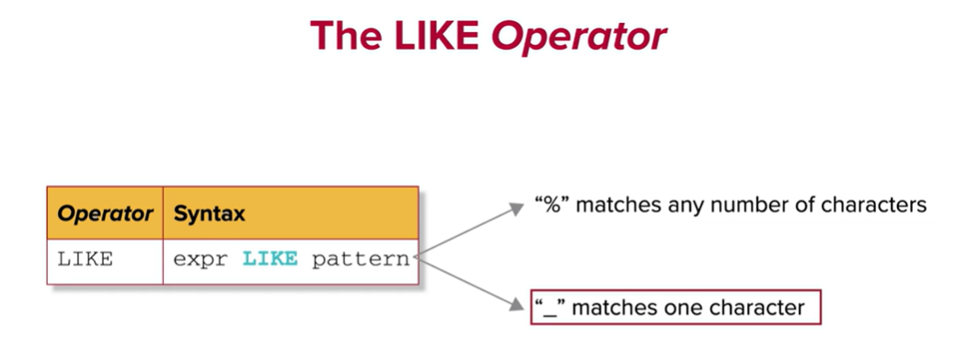

A Regular Expression is a sequence of characters that define a pattern to search for through text. Character *classes*, *anchors*, and *quantifiers* are all key factors when creating a Regular Expression.

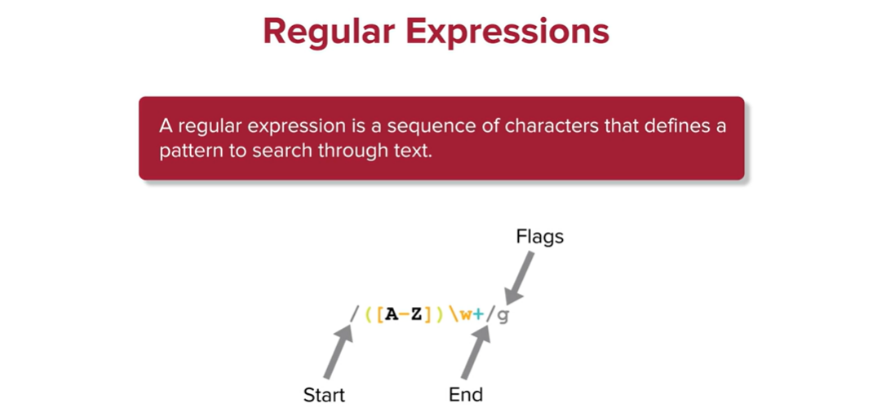

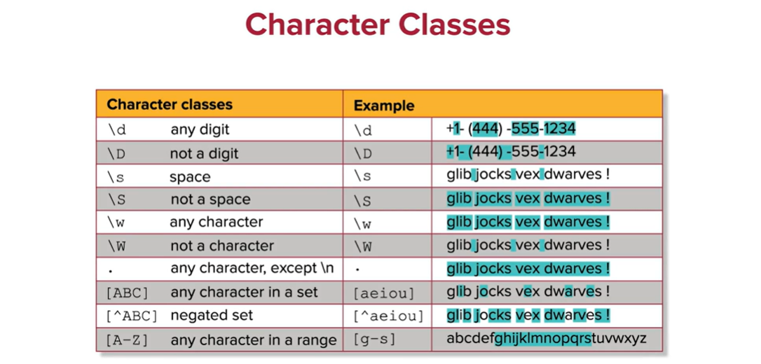

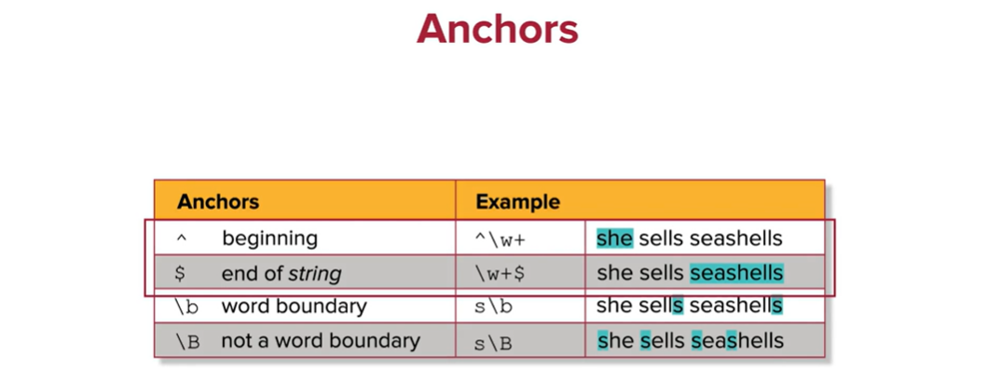

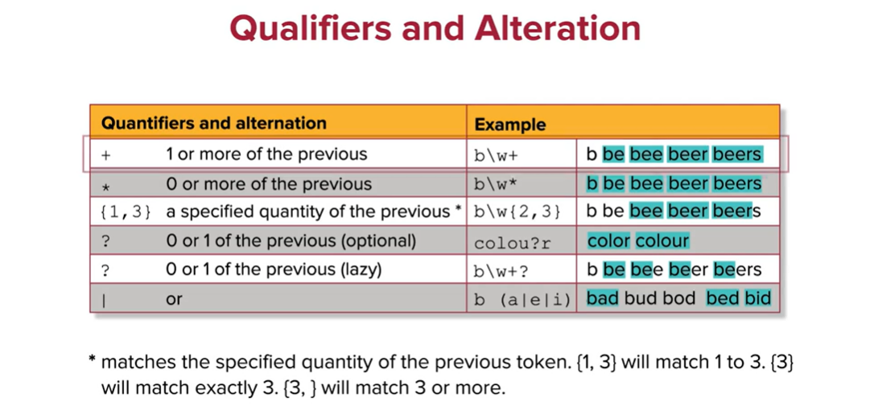

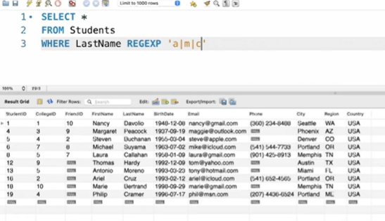

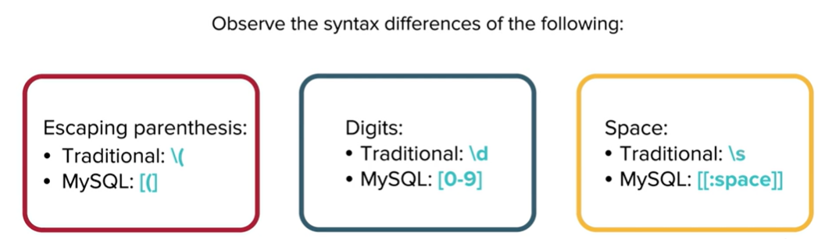

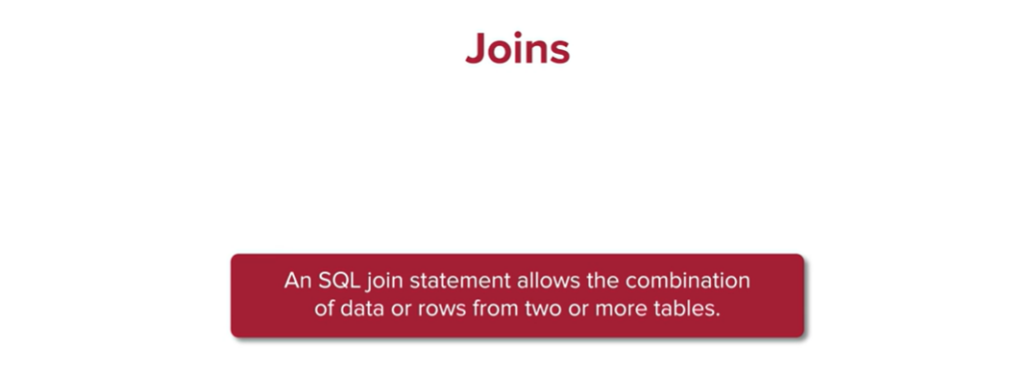

An inner *join* works by matching two tables together using a shared column:

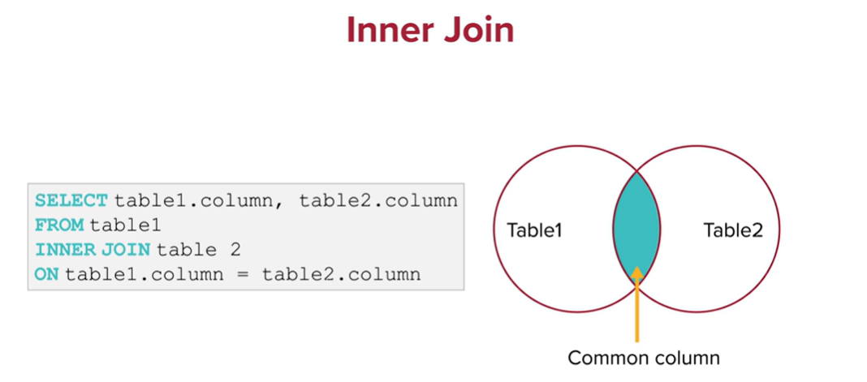

The self-*join* is a type of *join* that functions within a single table to *join* a table to itself. The purposes of a self-*join* are to combine information and compare data within a table:

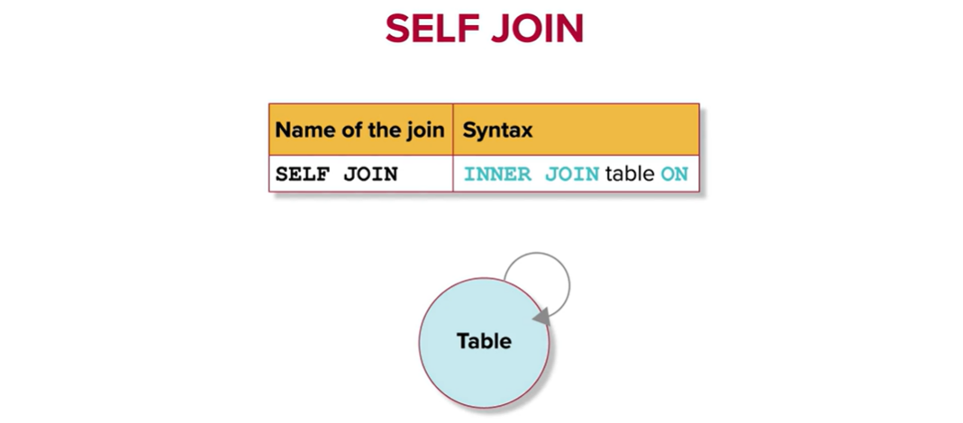

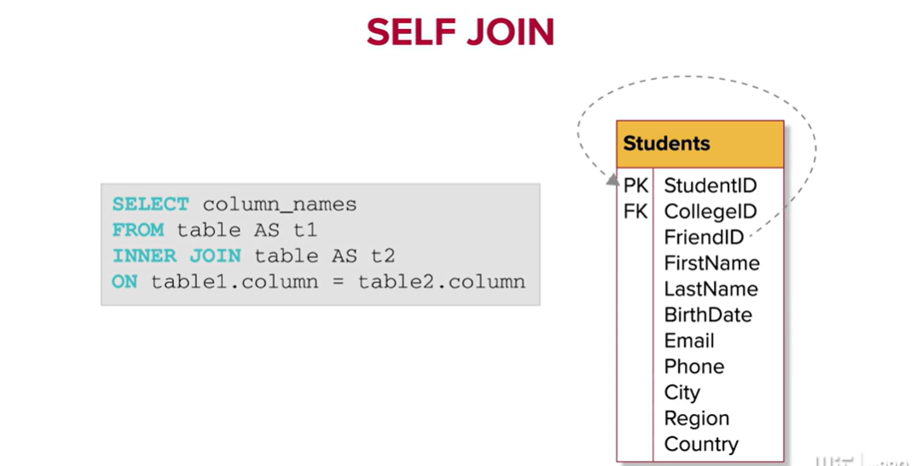

Multi-table *joins* can be used when you need to locate data from multiple tables together and combine it.

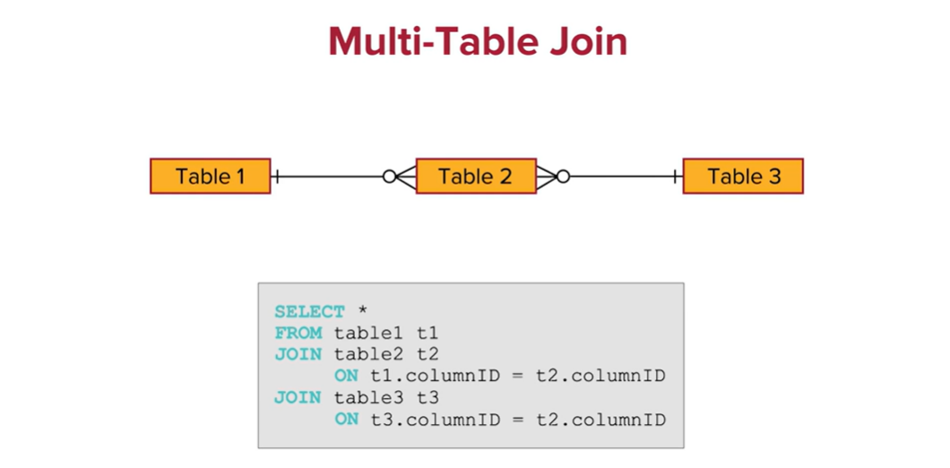

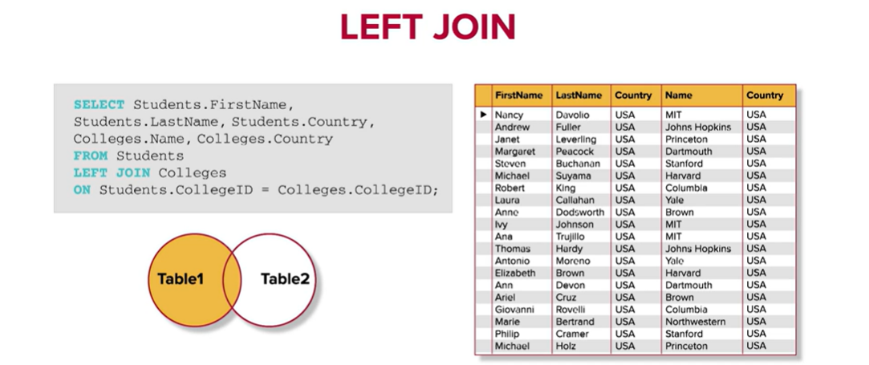

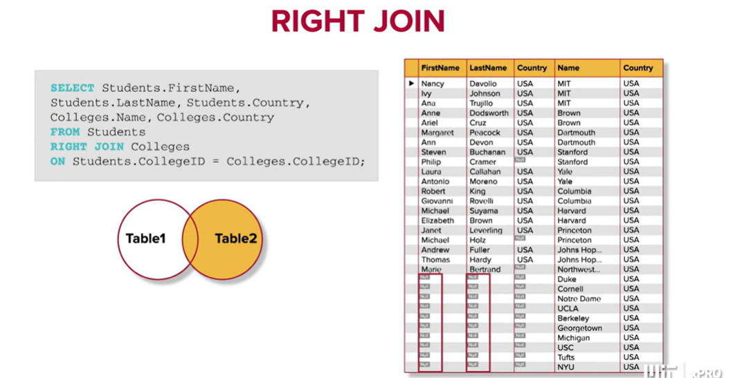

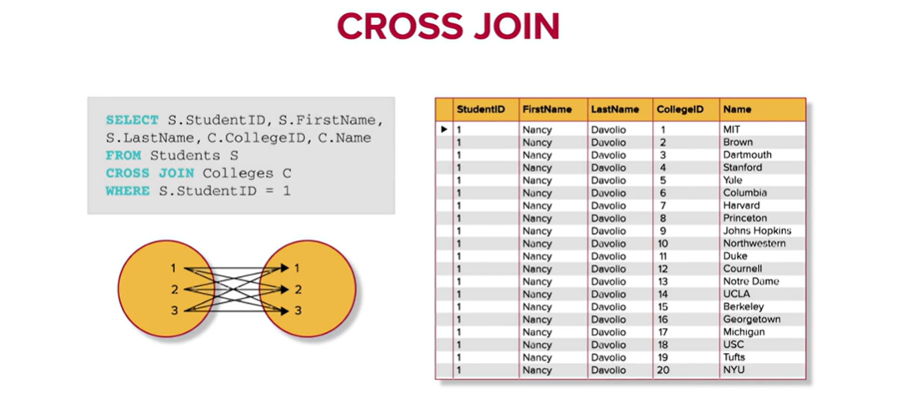

Default is ascending:

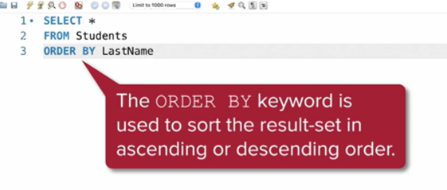

Aggregate data using the GROUP BY keyword:

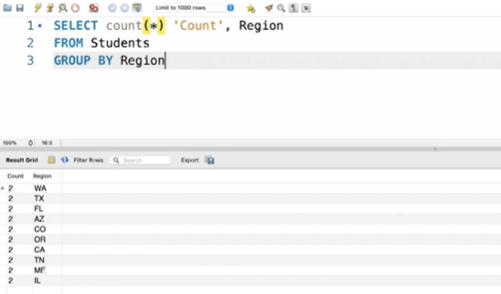

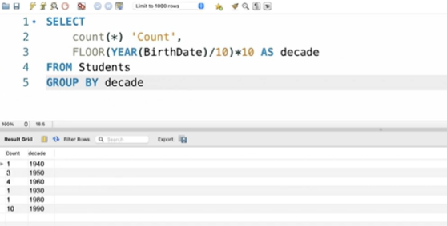

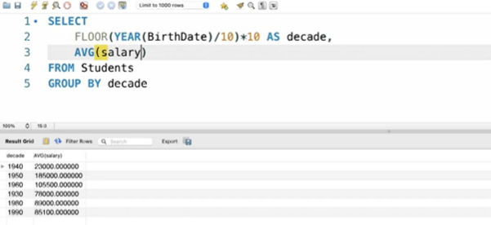

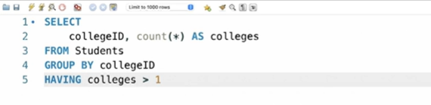

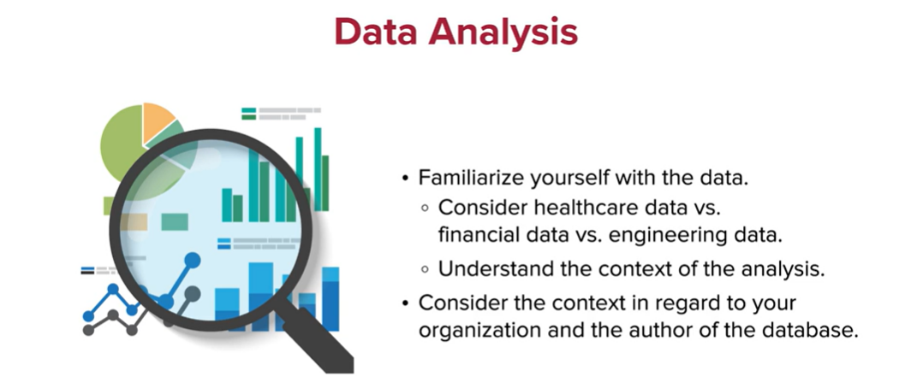

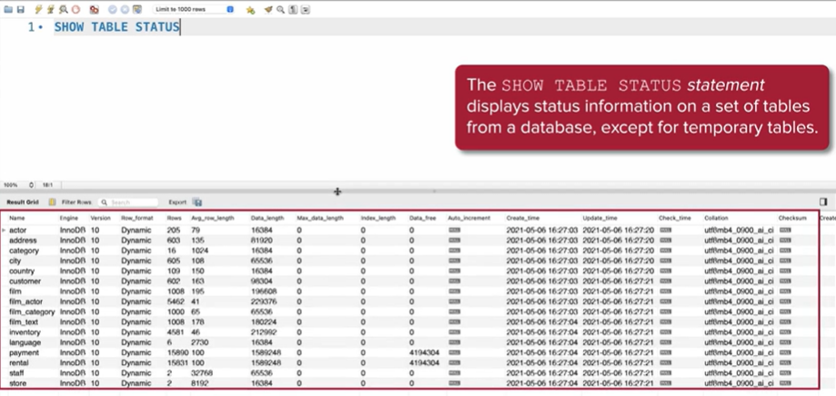

To create a quick histogram:

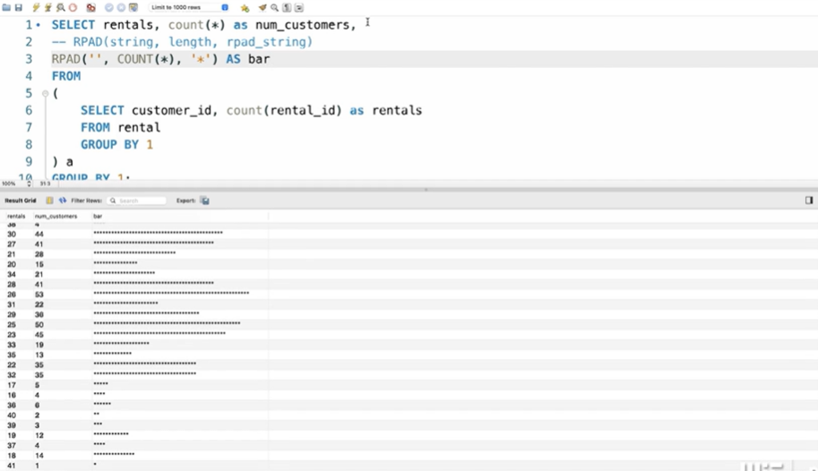

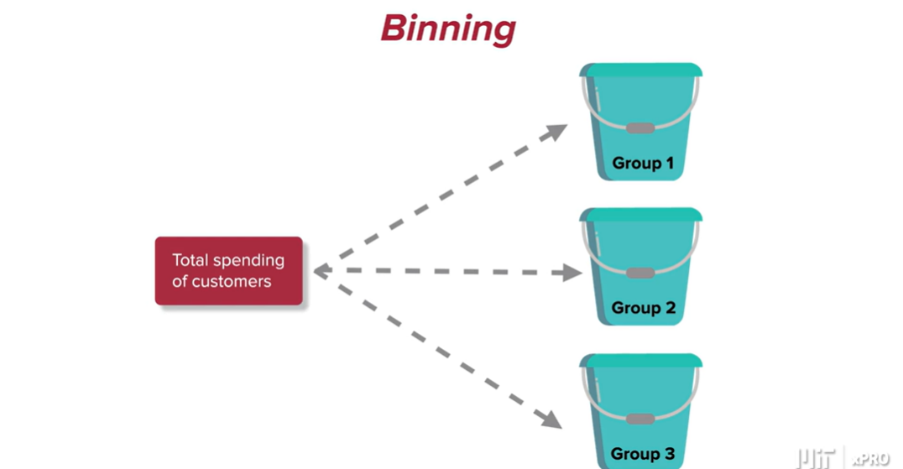

Binning for the amounts spent by customers:

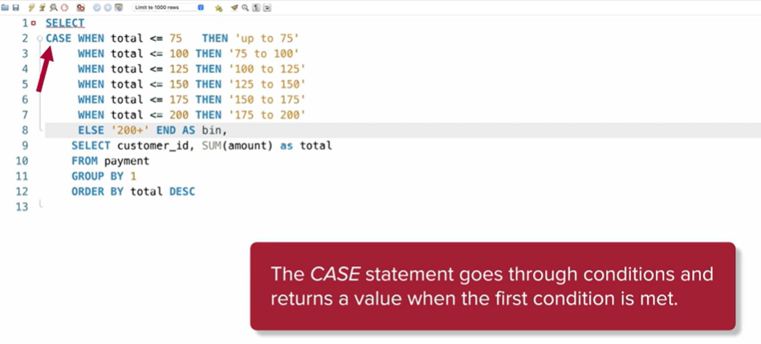

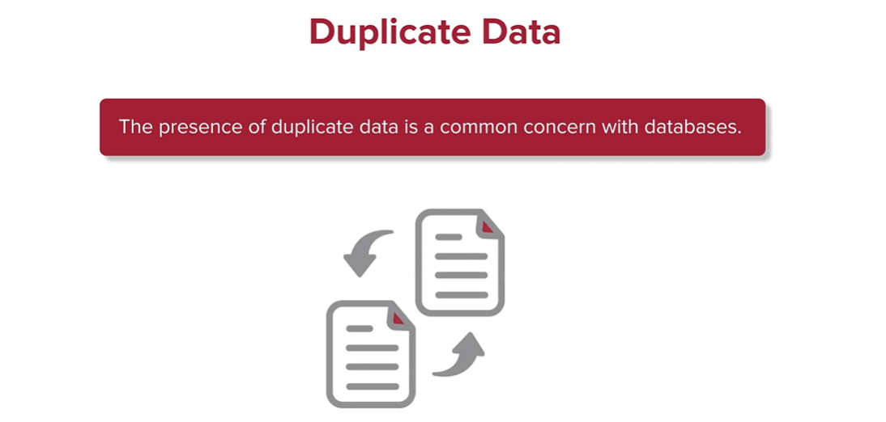

Run a query to perform a visual inspection:

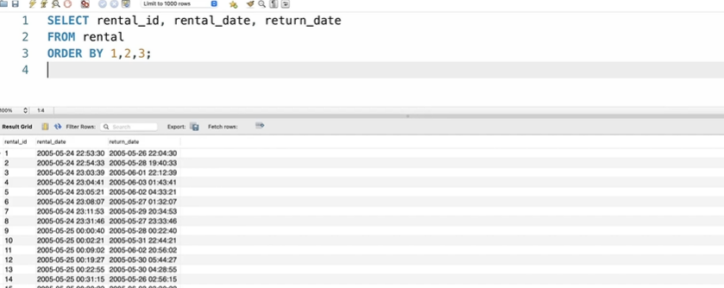

Run a query to count customers with >1 record:

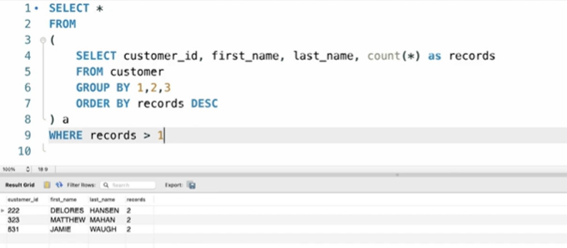

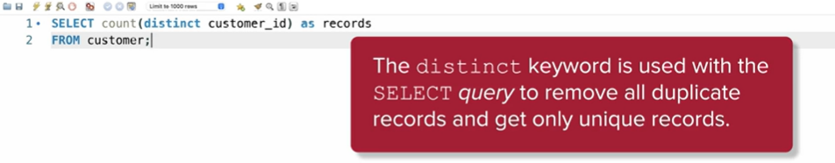

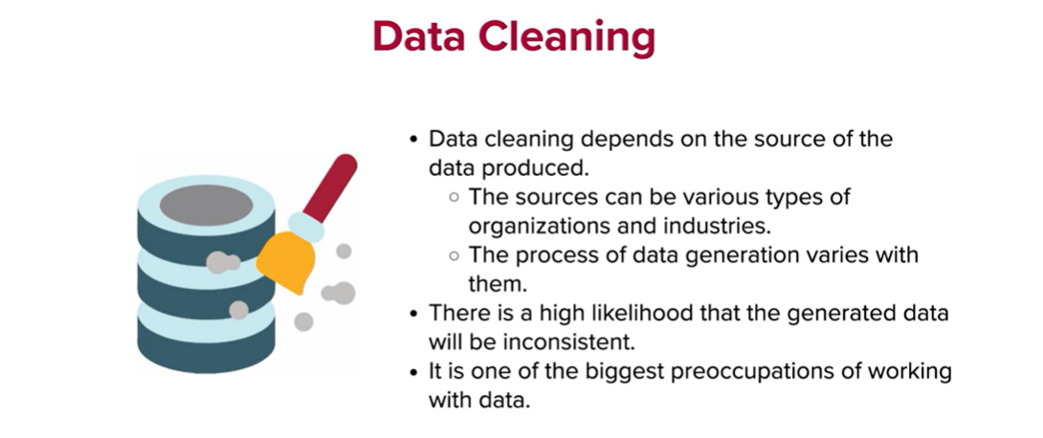

Check different entries in gender column:

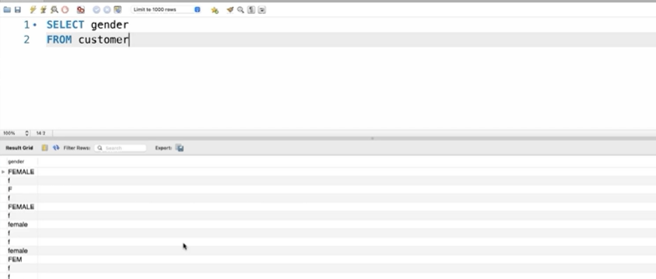

Create a new column with cleaned data::

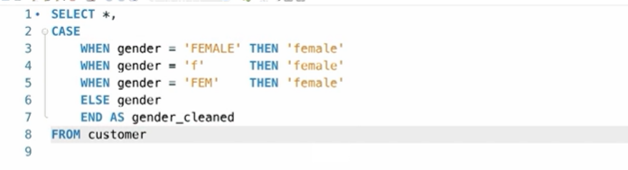

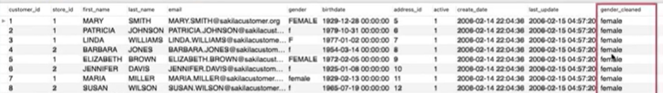

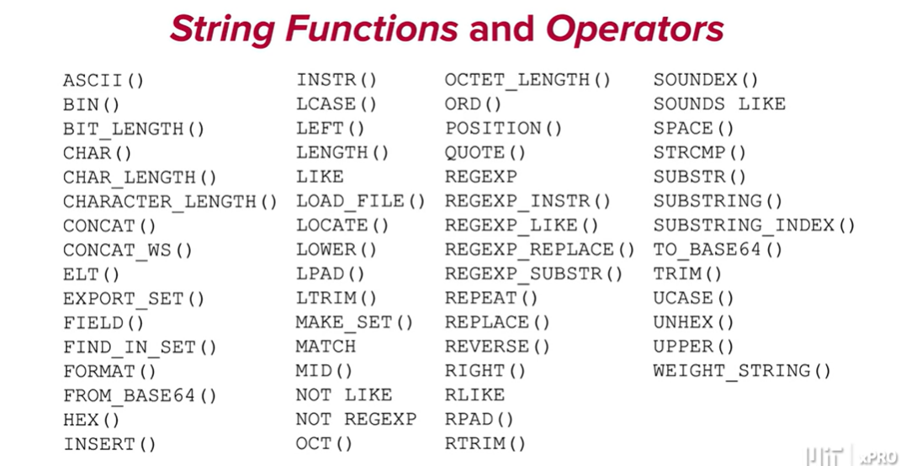

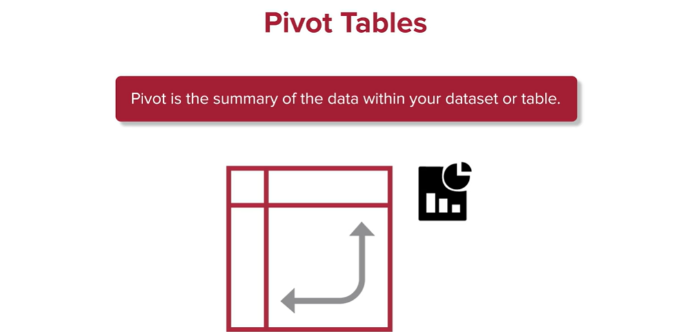

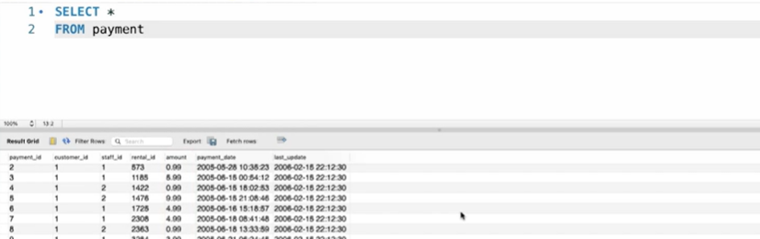

We now create a pivot table by summarising the payments per month:

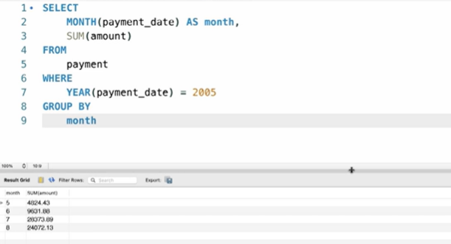

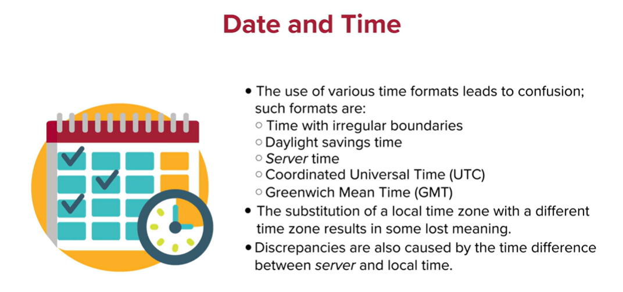

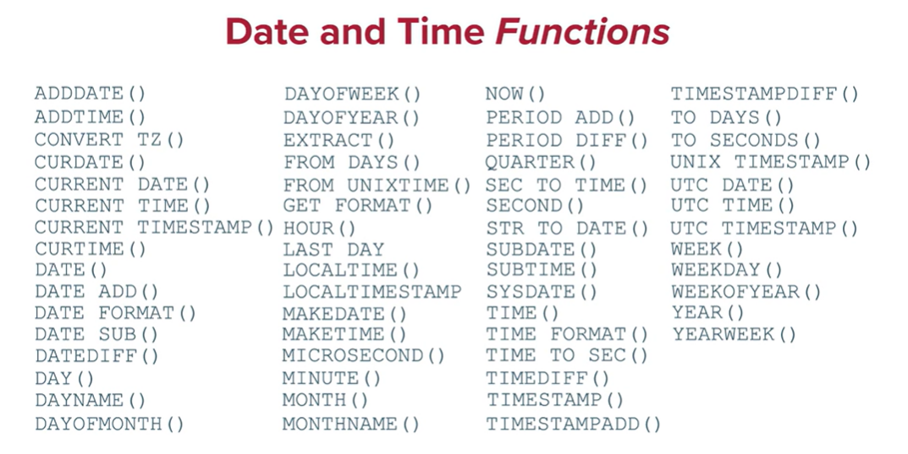

**What is *Normalization*?**

*Normalizing* data involves a set of practices that primarily aim to avoid redundancy in the data, improve integrity, and eliminate duplicate records.

When building out the details of a table, you may run into anomaly issues whenever adding, updating, or deleting data. *Normalization*, with its set of database organization practices, can help prevent that.

A database that has been *normalized* is considered a *Normalized Form*.

**What Types of *Normalized* Forms Exist?**

There are three types of *normalized* forms: *First Normal Form (1NF)*, *Second Normal Form (2NF)*, and *Third Normal Form (3NF)*. Let’s review each one of them in more detail.

The *1NF* ensures that any cell in your table contains only a single value. This can also be referred to as atomicity and it ensures that records can be accessed individually without the risk of unintentionally retrieving multiple values.

The *2NF* builds on the first form in the sense that the *2NF* cannot be enforced without having implemented the *1NF*. The goal of the *2NF* is to guarantee that every non-*key* depends on the entire *primary key*. In certain cases, one may want to separate a single table into smaller tables and assign a *primary key* to each table. Doing so guarantees the dependence of each value on a *key*.

Like the relationship between the *2NF* and the *1NF*, the *3NF* builds on the *2NF*. In the *3NF*, a non-*key* column cannot depend on another non-*key* column. In other words, if a column, say *A,* depends on a *primary key* column, then you cannot have another column, say *B*, also depend on column *A* and indirectly on the *primary key* column. As with *2NF*, a popular strategy to avoid this issue is to separate the original table into smaller ones and assign new *primary keys* to guarantee dependence.

**What Are Datatypes?**

After defining a table using MySQL, the next natural step is to start defining the data that each column will contain. During this process, MySQL requires you to specify the datatype in each column before adding the records to your table. In other words, specifying a datatype can be viewed as the process for establishing a certain type of data for your table.

In SQL, datatypes can be more specific than Python datatypes. Therefore, if you intend to avoid mistakes in your database (such as the loss of data and future analysis confusion), you must carefully decide the appropriate datatype for a column during the design process.

One useful keyword when defining a data type is `ASC`. This command ensures that entries in a table are ordered in ascending order.

**What Datatypes Does MySQL Include?**

MySQL holds many different datatypes, designed to capture numbers, characters, date and time, etc.

The table below summarizes the most common datatypes in MySQL:

**Common MySQL Datatypes**

| CHAR(*size*) | A fixed-length *string*. The *size* parameter specifies the length in characters. |
| --- | --- |
| VARCHAR(*size*) | A variable-length *string*. The *size* parameter specifies the length in characters. |
| BINARY(*size*) | Equal to CHAR(), but stores binary byte *strings*. |
| BIT(*size*) | A bit-value type. The parameter size specifies the number of bits in each record (from 1 to 64). |
| BOOL(or BOOLEAN) | In this datatype, zero is considered false, any other value is true. |
| ​​INT(*size)*(or INTEGER(size)) | An integer value. The *size* parameter describes how many digits should be visualized. |
| FLOAT(*p*) | A floating-point value. The parameter *p* is used to determine whether the record should be a regular floating-point number or a value. |
| DATE | A date in the format: YYYY-MM-DD. |
| DATETIME(*fsp*) | A date and time value in the format: YYYY-MM-DD hh:mm:ss. |
| TIME(*fsp*) | A time in the format: hh:mm:ss. |

Many other datatypes are supported by MySQL and an exhaustive list can be found in the [Official MySQL Documentation](https://dev.mysql.com/doc/refman/8.0/en/data-types.html)

***Indexing***

For tables in a database “*indexes* are used to find rows with specific column values quickly. Without an *index*, the *query* will begin with the first row and then read through the entire table to find the matching rows. It follows that the larger the table, the more this *query* costs. If the table has an *index* for the columns in question, the code can quickly determine the position to look for in the middle of the data file without having to look at all the data. This is much faster than reading every row sequentially (MySQL, 2021).”

**Why Should You *Index* a Table?**

The main reason for *indexing* a database is to efficiently retrieve data from your database. *Indexes* are particularly useful when working with large tables. In fact, when working with a table with many columns, *queries* can become lengthy. Choosing the column *indexes* appropriately can speed up your computations.

To understand why *indexing* is important, suppose the entries in a large table are not ordered alphabetically. If you were to look for a name (say, “Thom”), your *query* would look through every row in your table until it found the matching one. This could take a very long time. On the other hand, if the column with the names was *indexed*, you could retrieve the desired record much faster.

In other words, *indexes* allow you to create sorted *lists* without having to create new sorted tables that are not memory efficient.

**What Types of *Indexing* Can Exist?**

There are two types of *indexing* in SQL: clustered and non-clustered.

Clustered *indexes* are the unique *index* that uses the *primary key* to organize the data within the table. Clustered *indexes* are generated automatically when the table is created, and they use the *primary key* sorted in ascending order.

An example of a clustered *index* could be the contents of a phone book, keyed on (lastname, firstname).

One could open the book at “Thom Smith” and find all the information for all of the people that have “Smith” as their last name next to each other.

This makes clustered *indexes* great for retrieving data on range-based *queries* since all the data is located close together. Because clustered *indexes* are related to how the data is stored, there can only be one possibility for each table.

On the other hand, a non-clustered *index* is different because you can have many of them and they all point to the data in the clustered *index*.

Considering again the phone book example presented in the previous paragraph, one could define a non-clustered *index* keyed on (town).

Suppose now you had to search through the phone book for all the people who live in “London.” If you only used the clustered *index* from the previous example, you would have to search every single item in the phone book because the key on the clustered *index* is (lastname, firstname).

As a result, the people living in London are scattered randomly throughout the *index* and, therefore, the *query* would not run efficiently.

If you have a non-clustered *index* on (town) then these *queries* can be performed much more quickly.

**What Are Logical *Operators*?**

Logical *operators* allow you to test whether a condition is true or false. Therefore, the result returned by a logical *operator* is either true, false, or NULL (unknown).

You can think of a NULL result as an outcome that is undetermined. Therefore, it’s impossible to tell whether a comparison to NULL is true or false. Consider the following example:

(NULL = 1)

The comparison to NULL makes the first operand (i.e., the *boolean* expression you want to evaluate) unknown because it cannot be determined.

The focus of this mini-lesson is to review the logical *operators* you have seen in the previous video and how they operate.

**The AND *Operator***

The AND (or && ) *operator* is a logical *operator* that combines two *boolean* expressions. The AND *operator* returns true if both expressions evaluate to true. If one of the two expressions is false, then the AND *operator* returns false, even if one of the expressions is NULL.

The syntax for the AND *operator* in SQL is given by:

expression1 AND expression2;

The table below summarizes the results when comparing *boolean* expressions using the AND *operator*.

The AND *Operator*

|  | True | False | NULL |
| --- | --- | --- | --- |
| True | True | False | NULL |
| False | False | False | False |
| NULL | NULL | False | Null |

**The OR *Operator***

The OR (or || ) *operator* is a logical *operator* that combines two *boolean* expressions.

The syntax for the OR *operator* in SQL is given by:

SELECT column1, column2,

FROM table1

WHERE expression1 OR expression2;

The table below summarizes the results when comparing *boolean* expressions using the OR *operator*.

The OR *Operator*

|  | True | False | NULL |
| --- | --- | --- | --- |
| True | True | True | True |
| False | True | False | NULL |
| NULL | True | NULL | NULL |

**The NOT *Operator***

The NOT (or ! ) *operator* is a logical *operator* that combines two *boolean* expressions. It reverses the result of any logical *operator*.

The syntax for the OR *operator* in SQL is given by:

NOT [expression1];

The table below summarizes the results when comparing *boolean* expressions using the NOT *operator*.

The NOT *Operator*

|  | NOT |
| --- | --- |
| True | False |
| False | True |
| NULL | NULL |

**The XOR *Operator***

The XOR *operator* is a logical *operator* that combines two *boolean* expressions. It returns true if one expression is true, and false otherwise. If one of the expressions is NULL, then it returns NULL.

The syntax for the XOR *operator* in SQL is given by:

SELECT expression1 XOR expression2;

The table below summarizes the results when comparing *boolean* expressions using the XOR *operator*.

The XOR *Operator*

|  | True | False | NULL |
| --- | --- | --- | --- |
| True | False | True | NULL |
| False | True | False | NULL |
| NULL | NULL | NULL | False |

In summary, it is important that you learn and understand how logical *operators* and their tables work to guarantee correct results in your code.

A guide with details about additional *operators* can be found here: [SQL Logical *Operators*](https://www.sqltutorial.org/sql-logical-operators)

**What Are Regular Expressions?**

Regular Expressions (or RegEx) are expressions that are used to find patterns in a text block. One can use Regular Expressions to search for and find patterns in *strings* and can be used in nearly every language to validate user input, perform search tasks, or test code.

**How Do I Write Regular Expressions?**

Any Regular Expression is formed by a sequence of simple characters (i.e., alphabet letters, numbers), or by a combination of simple characters and special characters (i.e., symbols).

Any Regular Expression starts and ends with a slash symbol (/).

The simplest Regular Expressions are constructed of characters for which you want to find a direct match. For example, given the text “Hi, what’s your name?”, the RegEx /wha/ will return the exact pattern “wha” from the sentence in the example.

RegEx patterns are case-sensitive. In fact, given the sentence “Hi, what’s your name? What city do you live in?”, the RegEx used in the example above will only return the pattern “wha” and not “Wha”.

Sometimes, you may want to look for some more complicated patterns and a direct match may not be enough.

For example, to match a single “x” character, followed by zero or more "y” characters, and followed again by a "z" character, you would use the pattern /xy*z/. The asterisk symbol (*) after "y" means zero or more occurrences of the preceding item. In the *string* "xxxxyyyzzzxzyc", this RegEx will match the *substring* "xyyyz".

In addition to what you have learned about RegEx in Video 5.12, below are a few more rules to find advanced patterns in a code block or database entry.

**Writing *Assertions***

When writing Regular Expressions, *assertions* may include boundaries that indicate where your pattern should begin or end.

The table below summarizes the most common characters used for boundary-type *assertions*.

***Assertions***

| ^ | Matches the characters at the beginning of a text. For example, /^A/ matches “A” in the *string* “A beautiful day.” |
| --- | --- |
| $ | Matches the end of input. For example, /y$/ matches “y” in the *string* “A beautiful day.” |
| \b | Matches a word boundary where a word character is not followed or preceded by another word character. For example, the pattern /oon\b/ matches “oon” in the *string* “The moon is beautiful.” |
| a(?=b) | Lookahead *assertion* that matches "a" only if "a" is followed by "b". For example, the expression /Hello(?=World)/ matches "Hello" only if it is followed by "World", however “World” is not included in the search. |
| (?<=y)x | Lookbehind *assertion* that matches "a" only if “a" is preceded by "y". For example, /(?<=Hello)World/ matches "Worlds" only if it is preceded by "Hello". |

**Groups and Ranges**

Grouping expressions are used to find groups or ranges of words in a *string*.

**Groups and Ranges**

| a|b | Matches either “a” or “b”. For example, given the *string* “My shirt is red and green”, the expression /red|green/ returns “red” and “green”. |
| --- | --- |
| [a-b] | Matches any one of the enclosed characters between “a” and “b”. For example, /[a-c]/ in “abracadabra” matches “ab”, “aca”, “ab”, and “a”. |
| ^[a-b] | Matches anything that is not enclosed in the brackets. For example, /^[a-c]/ in “abracadabra” matches “r”, “d”, and “r”. |

***Quantifiers***

*Quantifiers* indicate the number of characters or expressions to match.

***Quantifiers***

| a* | Matches the preceding item "a" zero or more times. For example, /mo*/ matches “moo" in "The moon shines". |
| --- | --- |
| a+ | Matches the preceding item "a" one or more times. For example, /a+/ matches all the "a"'s in "caaaaaaandy". |
| a{n} | Matches the preceding item "a" *n* times. For example, /a{2}/ matches “aa” and “aa” in "caaandy". |

In summary, Regular Expressions can be very powerful and can be used to recognize and search for a variety of patterns. Applications of Regular Expressions include search and replace operations when creating applications to access features or data in an operating system (APIs) and to debug code.

**What Are *Joins*?**

In SQL, a *join* is a *statement* that allows the user to combine two or more tables with common *properties*.

Note that having common *properties* between the tables you want to *join* is fundamental. In fact, similar to Python, you cannot *join* two or more tables unless they have a common column.

**What Types of *Joins* Exist?**

There are four main types of *join*: INNER, LEFT, RIGHT, and FULL.

To understand how each of the above works, consider the following tables:

Students

| STUDENTID | NAME | PHONE | EMAIL |
| --- | --- | --- | --- |
| 1 | John | 123-345-4567 | john@mit.edu |
| 2 | Alex | 000-034-6758 | alex@mit.edu |
| 3 | Mary | 345-768-4959 | mary@mit.edu |
| 7 | Jessica | 485-936-9485 | jessica@mit.edu |

Courses

| COURSEID | STUDENTID |
| --- | --- |
| 123 | 1 |
| 456 | 2 |
| 789 | 3 |
| 486 | 8 |

**The INNER *Join***

The INNER *join* keyword selects all rows from both tables that satisfy the selected condition. This keyword will create a resulting table by combining all rows from both tables where the condition satisfies. The syntax to perform an INNER *join* is given by:

SELECT table1.column1,table1.column2,table2.column1,....;

FROM table1

INNER JOIN table2

ON table1.matching_column = table2.matching_column;

where table1 and table2 are the first and second table respectively, and matching_column is the column common to both tables.

For the above tables, the following *query*

SELECT Courses.COURSEID, Students.NAME, Students.EMAIL

FROM Student

INNER JOIN Courses

ON Students.ROLL_NO = Courses.ROLL_NO;

yields:

| COURSEID | NAME | EMAIL |
| --- | --- | --- |
| 123 | John | john@mit.edu |
| 456 | Alex | alex@mit.edu |
| 789 | Mary | mary@mit.edu |

**The LEFT *Join***

The LEFT *join* keyword returns all rows of the table on the left side of the *join* and matching rows for the table on the right side of the *join*. The rows on the left side that do not have a matching row on the right side will contain a NULL result-set*.* The syntax to perform a LEFT *join* is given by:

SELECT table1.column1,table1.column2,table2.column1,....;

FROM table1

LEFT JOIN table2

ON table1.matching_column = table2.matching_column;

Where table1 and table2 are the first and second table respectively, and matching_column is the common column to both tables.

For the above tables, the following *query*

SELECT Students.NAME, Courses.COURSEID,

FROM Student

LEFT JOIN Courses

ON Students.ROLL_NO = Courses.ROLL_NO;

yields:

| NAME | COURSEID |
| --- | --- |
| John | 123 |
| Alex | 456 |
| Mary | 789 |
| Jessica | NULL |

**The RIGHT *Join***

The RIGHT *join* keyword returns all rows of the table on the right side of the *join* and matching rows for the table on the left side of the *join*. The rows on the right side that do not have a matching row on the left side will contain a NULL result-set*.* The syntax to perform a RIGHT *join* is given by

SELECT table1.column1,table1.column2,table2.column1,....;

FROM table1

RIGHT JOIN table2

ON table1.matching_column = table2.matching_column;

Where table1 and table2 are the first and second table respectively, and matching_column is the common column to both tables.

For the above tables, the following *query*

SELECT Students.NAME, Courses.COURSEID,

FROM Student

RIGHT JOIN Courses

ON Students.ROLL_NO = Courses.ROLL_NO;

yields:

| NAME | COURSEID |
| --- | --- |
| John | 123 |
| Alex | 456 |
| Mary | 789 |
| NULL | 486 |

**The FULL *Join***

The FULL *join* keyword creates the result-set by combining the result of both the LEFT *join* and the RIGHT *join*. The result-set will contain all the rows from both tables. The rows which do not have a matching value will contain NULL result-setvalues.The syntax to perform a FULL *join* is given by:

SELECT table1.column1,table1.column2,table2.column1,....;

FROM table1

FULL JOIN table2

ON table1.matching_column = table2.matching_column;

Where table1 and table2 are the first and second table respectively, and matching_column is the common column to both tables.

For the above tables, the following *query*

SELECT Students.NAME, Courses.COURSEID,

FROM Student

FULL JOIN Courses

ON Students.ROLL_NO = Courses.ROLL_NO;

yields:

| NAME | COURSEID |
| --- | --- |
| John | 123 |
| Alex | 456 |
| Mary | 789 |
| Jessica | NULL |
| NULL | 486 |

In conclusion, it’s important to master all the different types of SQL *joins* to combine tables in the most efficient way possible and obtain the best insight into your data.

**What Are Histograms and Why Are They Important?**

A histogram is a chart that *plots* a variable, such as time, against the number of occurrences in the variable category. A histogram takes continuous measurable data, such as temperature, distance, and weight, and displays its distribution. The picture that a histogram provides about the distribution of your process outcomes can help you determine how or where there may be a problem.

Therefore, histograms are a powerful tool to visualize the distribution of your data and get a sense of the variation of the data as the values change. Being able to produce histograms is an important skill for you to gain insights about your data.

Histograms can be created in various programming languages. In this mini-lesson, the differences between histograms in Python and SQL will be presented.

**Histograms in Python**

As you learned in Module 2, histograms in Python can be created with the help of *plotting libraries* such as Matplotlib and Seaborn.

Regardless of which l*ibrary* you use, histograms in Python are highly customizable meaning that the *plot* can be modified according to the user’s needs.

Let’s review how histograms are created using Matplotlib.

Consider the following code:



The code above will produce the following output:



You can see that a histogram for the data x has been created. Note that the code above uses the default settings (for example, the color of the *bins*) for the hist() *function*, but the graph can be customized based on your needs by looking at the documentation of the *function* in [Matplotlib](https://matplotlib.org/stable/api/_as_gen/matplotlib.pyplot.hist.html?highlight=hist#matplotlib.pyplot.hist). Additional customizations can also be added, such as axis labels, a title, and a legend.

Another approach to creating histograms in Python is by using the Seaborn *library*. Although you have not experimented with this *library* much so far, you have seen that it is often used in statistics in the Try-It activity in Module 2.

Let’s review how histograms can be generated in Seaborn.

Consider the code below:



In the image above, the kde *argument* in the distplot() *function* is used to visualize the continuous distribution that fits the histogram. In this case, the kde is set the False, so it has been disabled and will not display the histogram. You can display the histogram by setting the *argument* equal to True. The output for the code is:



You may notice that the histograms produced by Matplotlib and Seaborn look a little different in terms of layout, even though they represent the same data. Similar to Matplotlib, the graphs produced in Seaborn are highly customizable. It’s generally up to you to decide which *library* to use depending on your preference.

**Histograms in SQL**

In the previous video, you learned that it is possible to visualize the distribution of some rudimentary yet useful histograms to visualize the distribution of the records in a database.

The fact that histograms in SQL are very simplified compared to the ones that can be created in Python is due to the fact that SQL does not support or use *libraries* to create *plots*. Therefore, histograms must be created by using a padding *function* that displays how many times a certain value appears.

As a review, consider the following SQL code:



For the table rentals, the code above produces the following histogram:



This histogram is much simpler, and it is not customizable, unlike the ones that can be produced in Python, so it is important to understand how different types of histograms can be created and that they can provide quite useful insights about your data.

**Why Is Data Cleaning Important?**

Data often comes in a format that is not quite ready for efficient analysis. In fact, to perform an accurate analysis, it is of paramount importance that the data is in a tidy format.

Regardless of the programming language you use, “Data cleaning is the process of detecting and correcting (or removing) corrupt or inaccurate records from a record set, table, or database and refers to identifying incomplete, incorrect, inaccurate or irrelevant parts of the data and then replacing, modifying, or deleting the dirty or coarse data” (Wu, 2013).

**Cleaning Data in SQL**

In a similar way as you have seen for Python, cleaning data in SQL includes a set of techniques that are normally performed by developers or programmers when the data doesn’t come in an easy-to-use format.

In this mini-lesson, some of the most common and important ways to clean data are presented.

**Dealing with Different Data Types**

As you have learned so far, when a database is presented to you, the most common data types are numeric, *string*, and datetime. In the case of numeric data types, a problem you may encounter is that the data comes in a numeric data type that does not suit what that *property* really describes.

For example, suppose you have a table with a column Age and that this column contains *floats* so that the ages are really written as 10.0, 34.0, etc. In this case, it would be a good idea to convert these values to integers, as it doesn’t make sense to have an age expressed as a *float*.

Another issue may arise when dealing with zero values. Consider the following example. Suppose that your table also has a column titled BloodPressure, that contains zero values. This doesn’t make sense either, since the blood pressure of a living person cannot be zero. In this case, it would be a good idea to replace the zero values with more meaningful entries, such as the average blood pressure for all the individuals in that table.

In general, it is always important to deal with erroneous or NULL entries to ensure an accurate analysis. Like in Python, the two most common techniques for data cleaning in SQL are:

* Removing the entries containing missing/null values (not recommended)
* Imputing the missing/NULL entries with a numeric value (typically the mean or median of the respective column)

Another situation where you may have problems when dealing with data that is not clean is table joining*.* Consider the following scenario. Suppose that you want tojoin two tables, MedicalRecords and Prognosis, on the key PatientID. Assume further that PatientID is in integer format in the first table and in *float* format in the second one. When you try to join the two tables, you will encounter an error because the data types for the same column in each table are mismatched.

**Dealing with *Strings***

*String* values are also very common in databases. An issue you may face is that within the same column, values that are supposed to represent the same value are written in a different way.

For example, in the MedicalRecords table above, you may have a column, CardioExams, which represents the type of exam a patient had to undergo. If this column contains values such as “EKG” or “ECG,” which both describe the same type of exam (electrocardiogram), this may cause inaccuracy when grouping data.

**Dealing with Dates and Times**

The most common problem that arises when working with data in a date or time format in SQL is that although the entries appear in date or time format, they are not actually saved as the appropriate data type.

A solution to this is to cast the original entries into the proper format to allow manipulation and analysis.

In general, when cleaning data of any data type in SQL, you must pay attention to the following:

* You must ensure that the data is in a proper format in accordance with the quantity it represents.
* You must make sure that all erroneous, missing, or NULL values are accounted for.
* You must make sure that the data across tables or within each column is consistent.